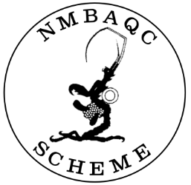

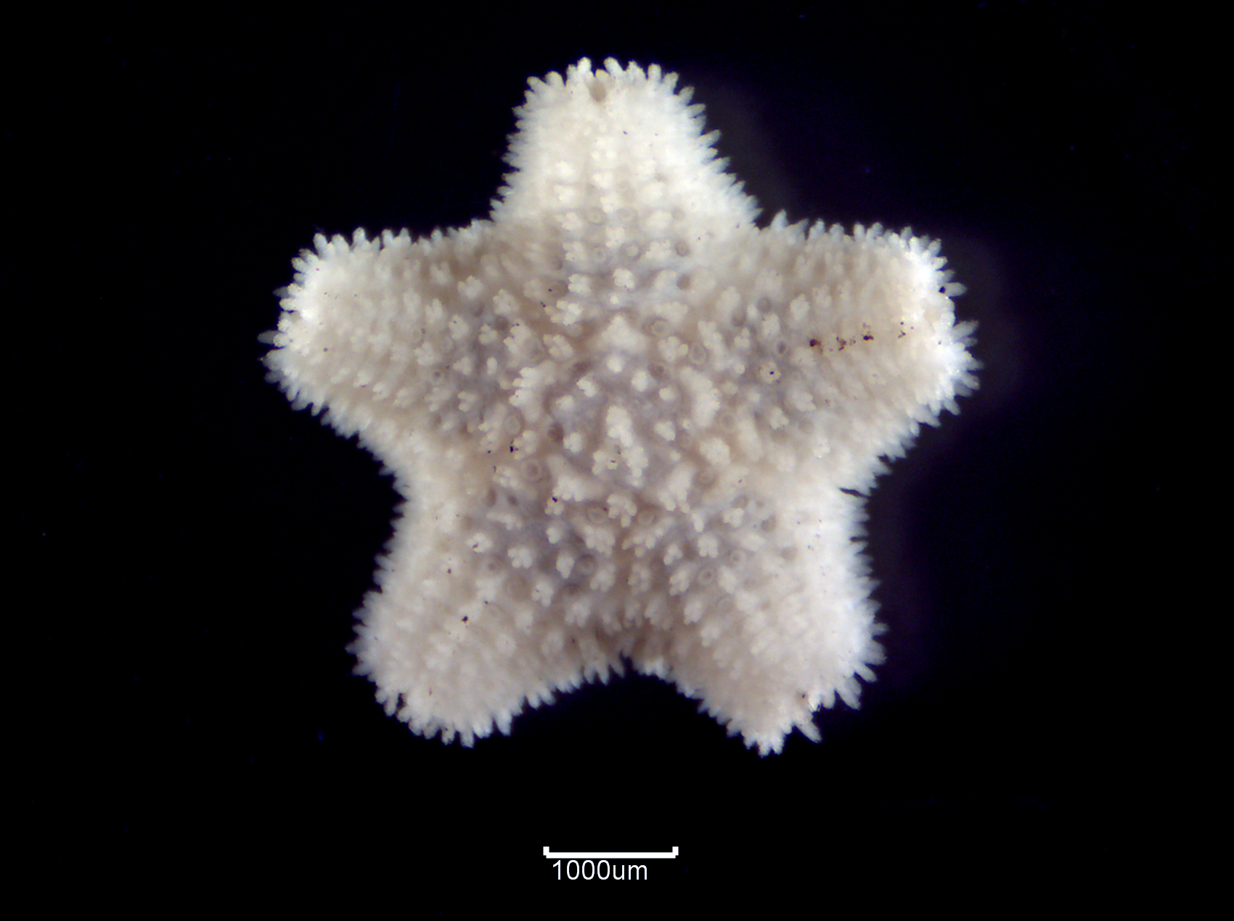 | 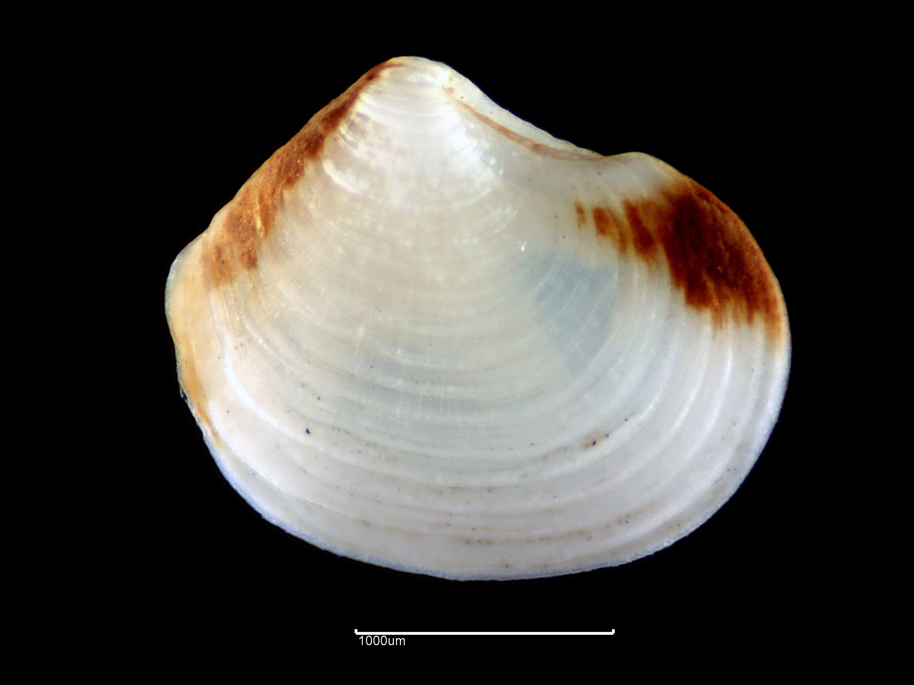
Asterina gibbosa ©APEM | Lucinoma borealis ©APEM

2023 Benthic Invertebrate Taxonomic Workshop for Beginners
Expression of Interest / Booking Form

26th – 30th June 2023
Martin Ryan Marine Science Institute, University of Galway, Galway, IE

The NMBAQC Scheme was set up to provide quality control/assurance to the macrobenthic invertebrate elements of the Clean Seas Environmental Monitoring Programme (CSEMP; formerly the NMMP); it has since provided the external quality assurance for statutory monitoring to report to Government and the EU. These reporting requirements have led to the NMBAQC diversifying into other biological disciplines. The elements of the Scheme are detailed in the NMBAQC website.

The macrobenthic component aims to improve the quality of macrobiota identification through practical workshops. Workshops are tailored to meet some of the current training needs reflected by participating laboratories in the Scheme.

The 2023 Workshop aims to:
- provide an introduction to the best practice processing methods for macrobenthic samples with practical training on the extraction of fauna from various types of sediment;
- educate early career benthic biologists and enthusiasts in the identification of major faunal groups encountered in UK and North-East Atlantic waters, with a combination of theory sessions from experienced marine scientists and practical sessions with over 5,000 reference lots from our Marine Reference Collection;
- provide a venue for relaxed, but effective and supportive training.

The expression of interest form below is for places at the 2023 NMBAQC Scheme Taxonomic Workshop for Beginners. All are welcome; however, places are limited so priority will be given to current NMBAQC participants. Please note that, as this is a self funded workshop, refunds for cancellations cannot be given after 19th May 2023.

The Date:
26th to 30th June 2023

The Venue:
MRI Annex Lab, Martin Ryan Marine Science Institute, University of Galway, Galway, Ireland.

The Organisers:
APEM Ltd. and University of Galway on behalf of the North East Atlantic Marine Biological Analytical Quality Control (NMBAQC) Committee

General format:

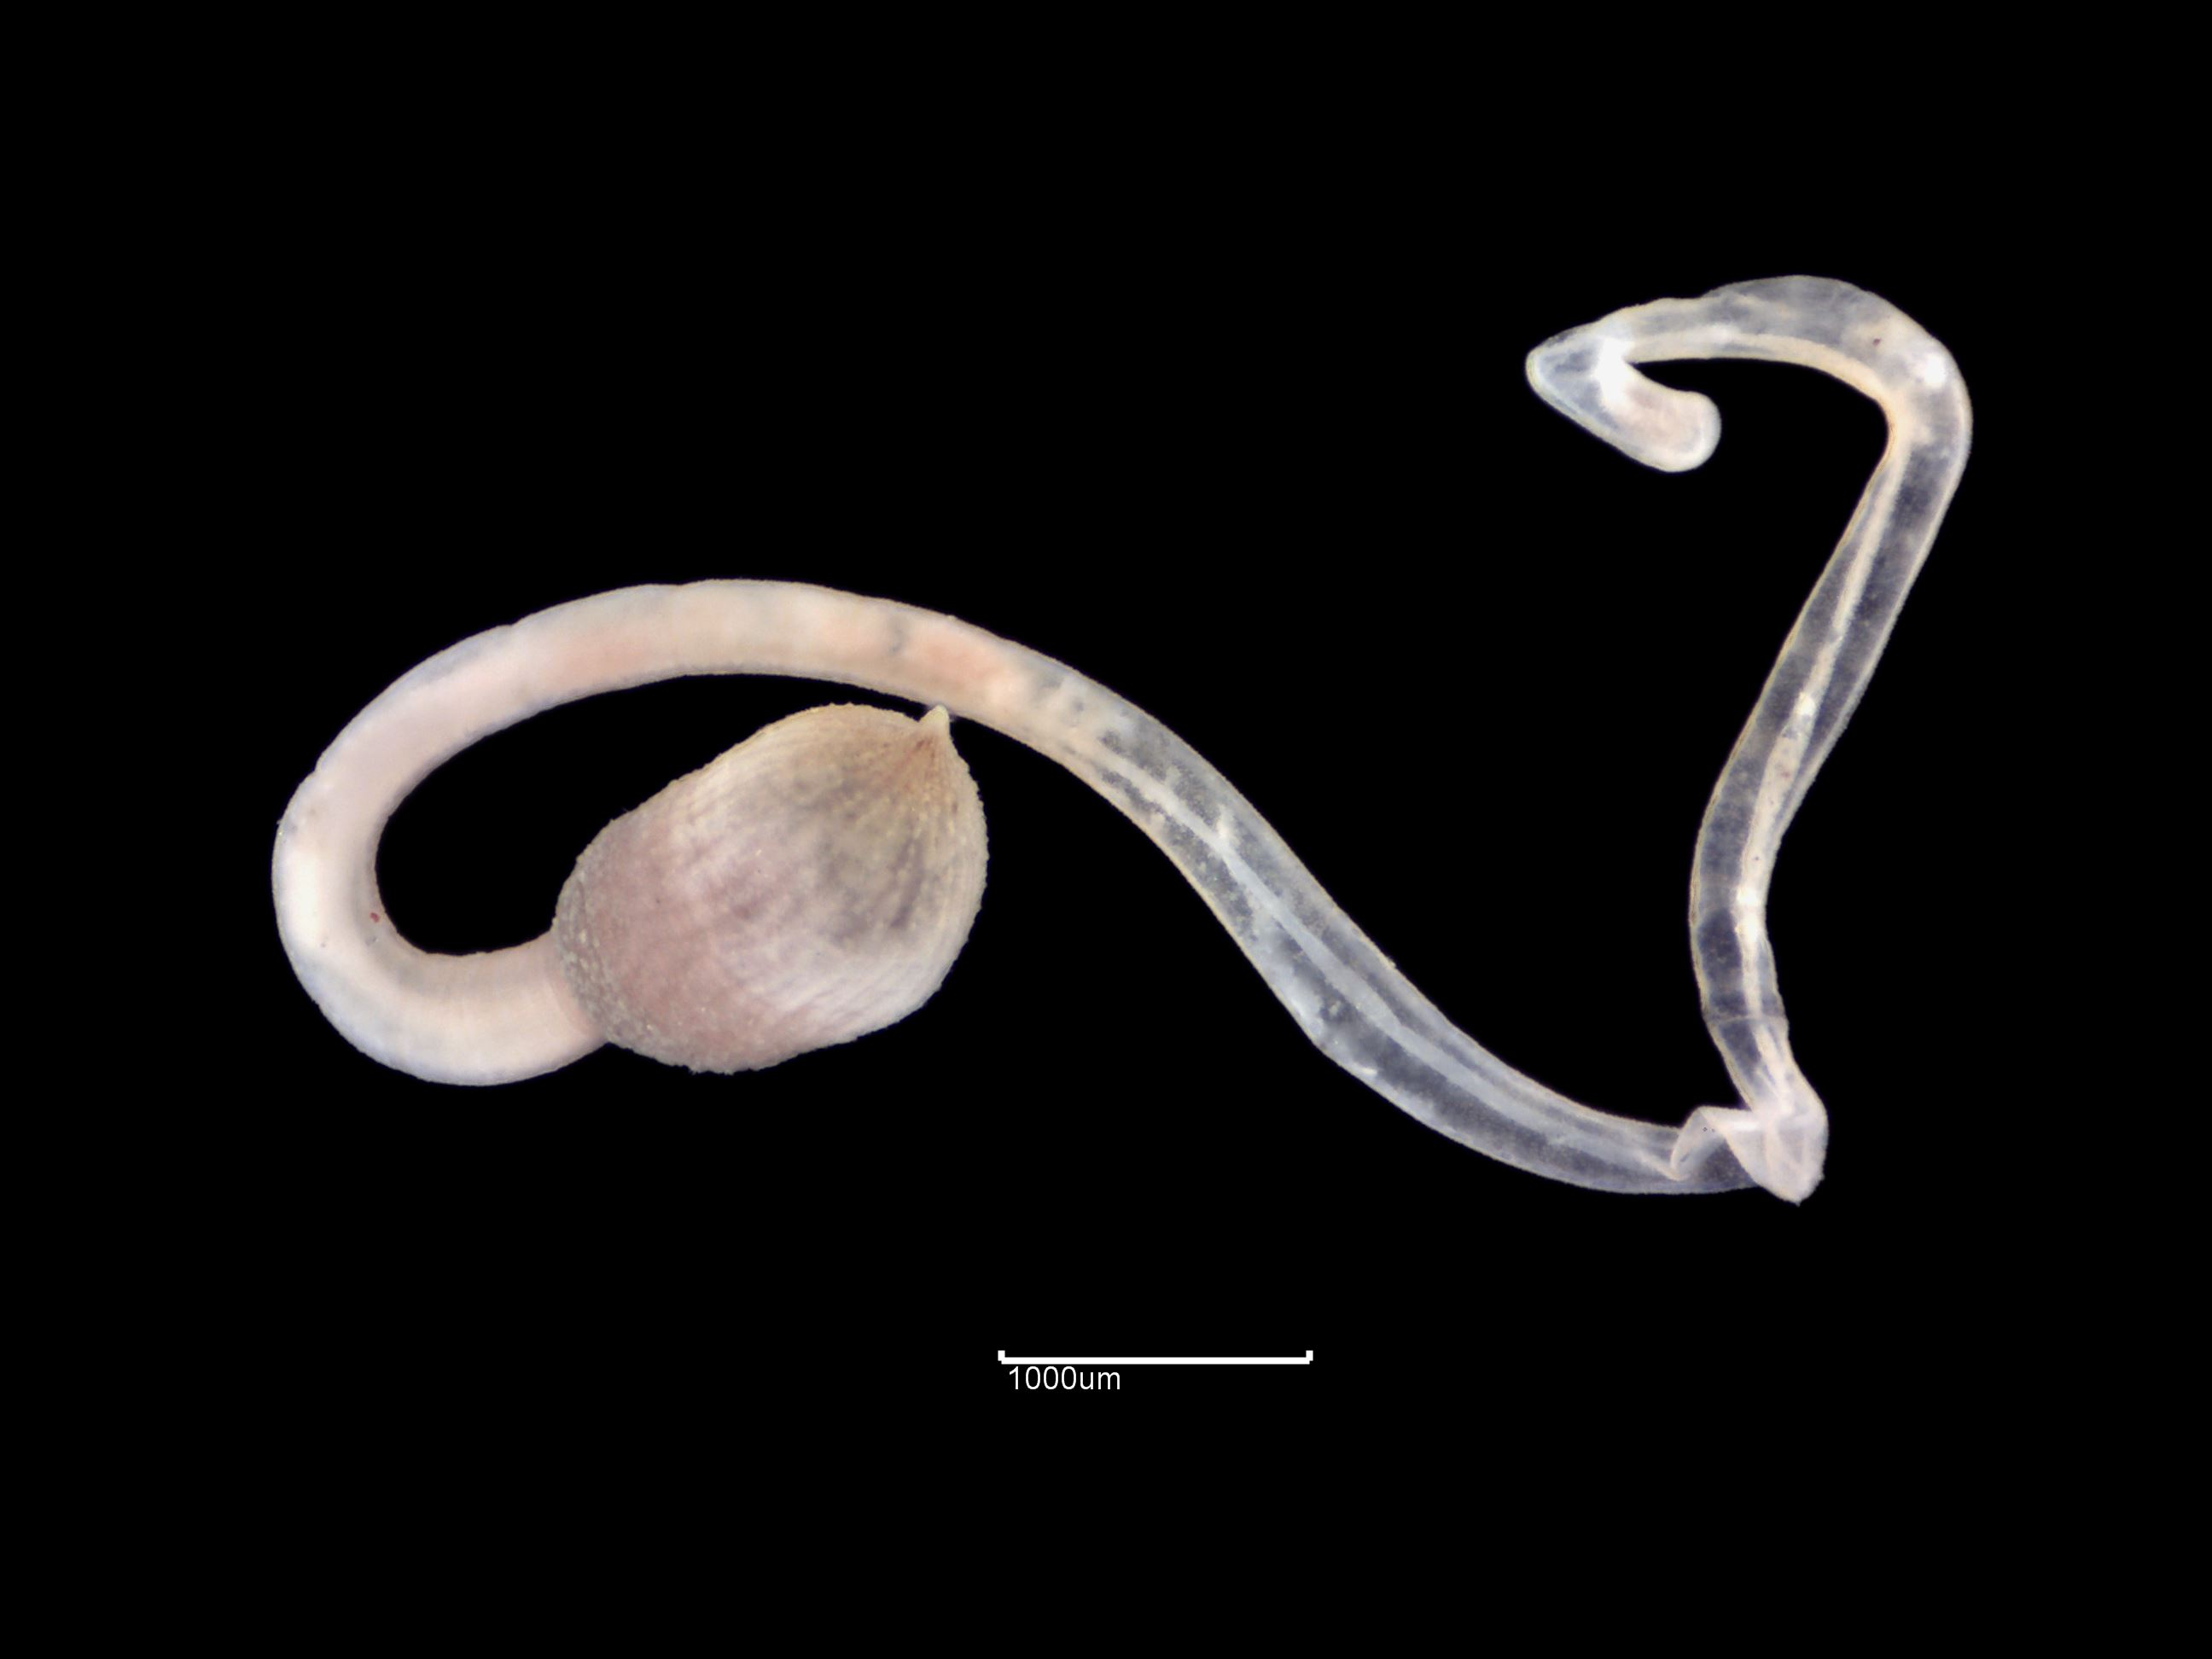 | The workshop will last 5 days and, after a brief introduction on all the faunal groups that can be found in a marine/estuarine macrobenthic sample, we will cover the four Major Taxonomic Group, Polychaeta, Crustacea, Mollusca (Bivalvia and Gastropoda) and Echinodermata, in more detail.
Onchnesoma steenstrupii ©APEM

Each of the four Major Groups will be treated on separate day, with an introductory talk in the morning to provide an overview of the principal morphological characters and Families, and practical observation of specimens from our Reference Collection in the afternoon. | 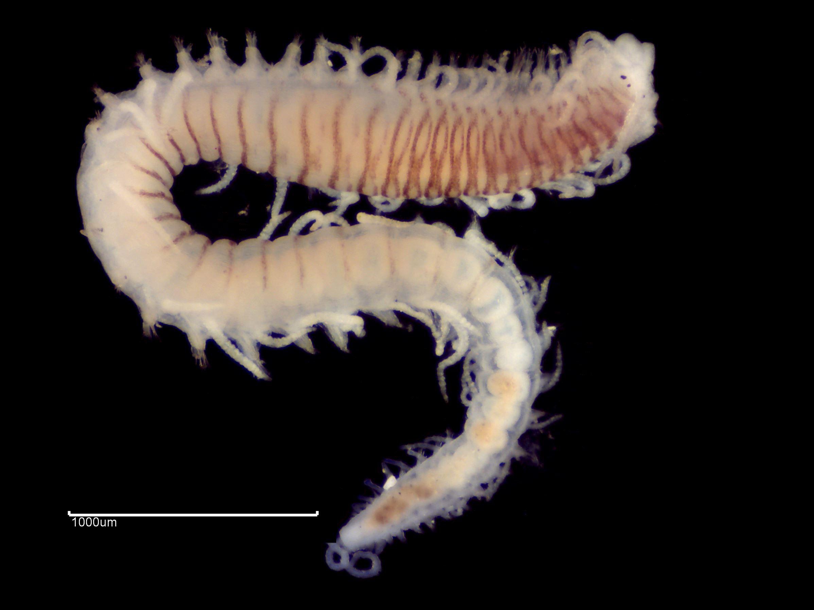
 | Syllis variegata ©APEM
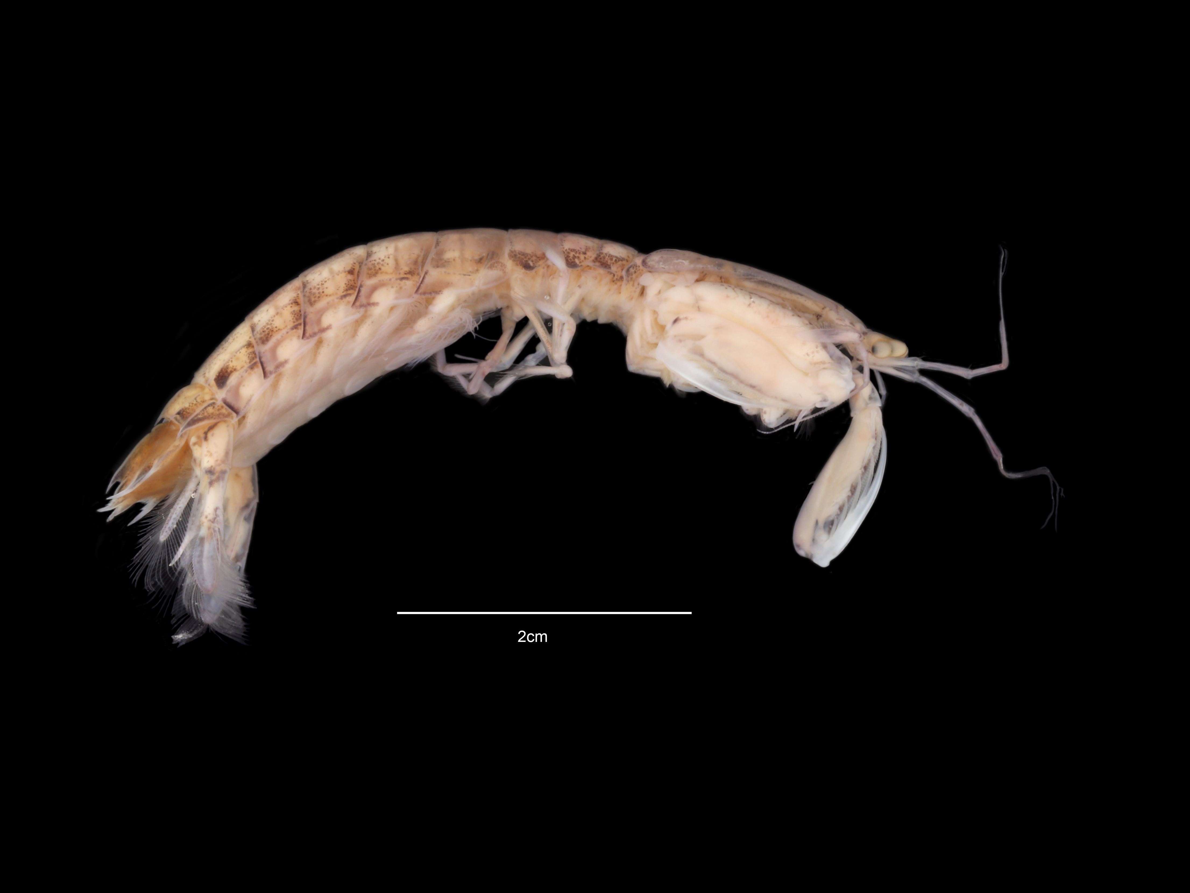 |  | This year we will re-introduce a section on sample processing, with particular emphasis on the extraction of the fauna from the sediment.
Rissoides desmaresti ©APEM

The Cost:
The estimated fee for the workshop is £950+VAT per participant. This cost is based on a minimum of 15 attendees. Additional attendees (greater than 15) will result in a reduced cost per person, final costs will be advised the w/b 26th May 2023.
Costs cover expert tuition and break time refreshments (tea/coffee, etc.), but exclude all meals and accommodation.
Conditions:
Invoices will be sent upon receipt of a booking form and following confirmation of the workshop in May 2023. The finalised programme will be forwarded as soon as it is available.

Participants will have access to basic microscopes and other equipment (forceps, dishes, alcohol, etc.) but may wish to bring their own laboratory microscopes and cold light sources (equipment requirements must be stated on the booking forms). Please inform us at the time of booking if you will have your own microscope/light source.

Summary:
Single participant = £950 + VAT
The fee excludes accommodation and subsistence (see accommodation options and local restaurant/café details).

A full workshop timetable will be available soon. Participants should note that the workshop session commences at 10.00 am on the Monday, at 9.00 am the following days, and finish at 5.00 pm every day.

2023 Benthic Invertebrate Taxonomic Workshop for Beginners
Expression of Interest / Booking Form

Name: ……………………………………………………………………………………….....

Laboratory:…………………………………………………………………………………...

I would like to express and interest in place(s) to attend the Taxonomic Workshop for Beginners (please insert number).

I understand that my expression of interest will remain provisional until the workshop is confirmed on 19th May 2023, after this date any cancellations will be non-refundable.

Participant details and attendance options:

 | Participant 1 | Participant 2 | Participant 3 | Participant 4 | Participant 5 | Participant 6
Name
E-mail
Telephone
Taxonomic Workshop 26th-30th June 2023
Microscope Required, i.e. not bringing own equipment
Special Requirements
Sub Total £
Total £
Invoice Address
Purchase Order No.
Please return this form as soon as possible to:
Graham Phillips (graham.phillips@environment-agency.gov.uk) and cc TBC
Estuarine and Coastal Monitoring and Assessment Service, Environment Agency, Goldhay Way, Peterborough, PE2 5ZR

