Benthic Invertebrate Workshop 2014
The Expert Benthic Invertebrate Workshop 2014 was a great success, and here are some of the photos of the workshop, which show:
Bastian Brenzinger, of the Bavarian State Collection of Zoology, presenting on interstitial opisthobranchs to the workshop participants;
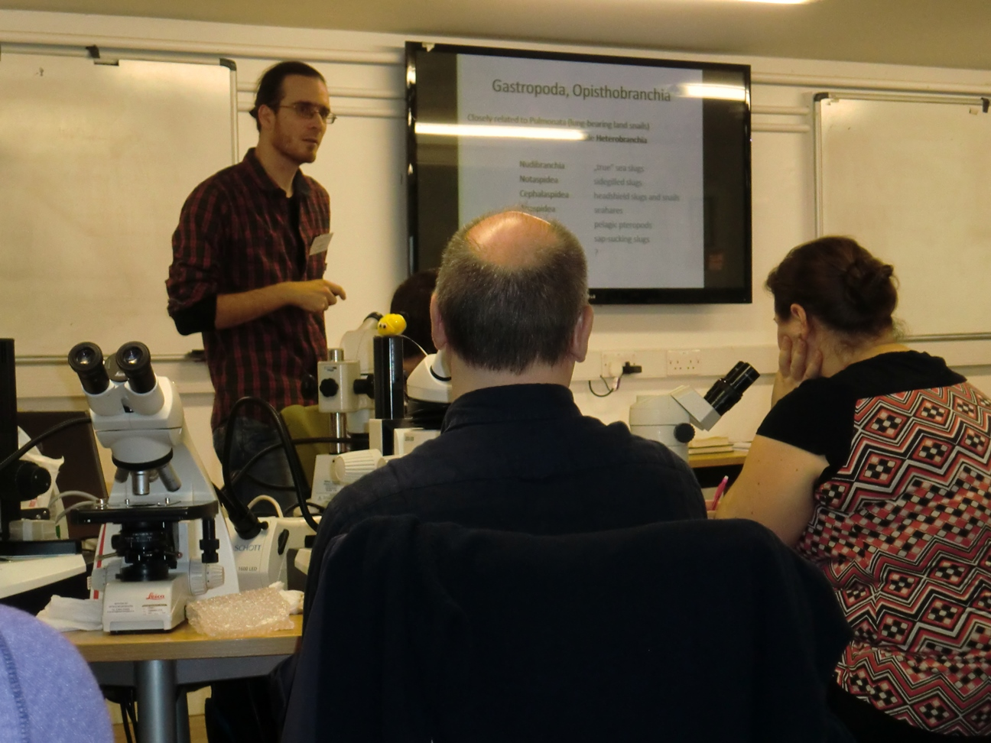
Professor Adriana Giangrande, of the University of Salento, presenting on fabricids and sabellids to the workshop participants;
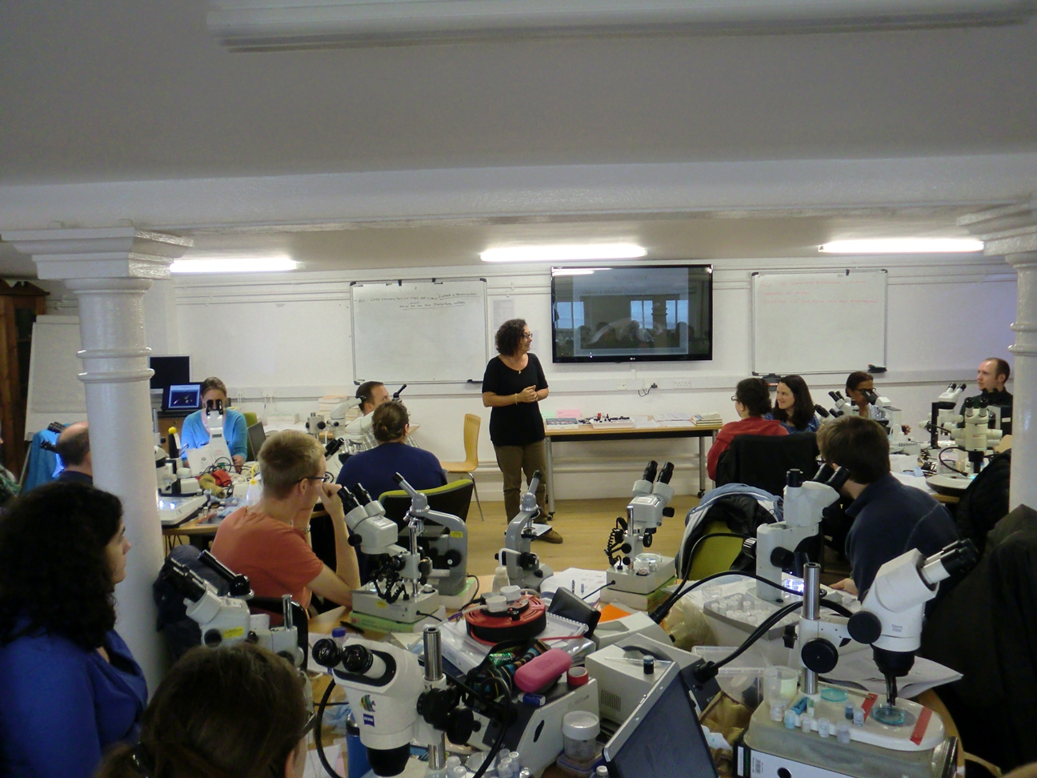

Three general views of the laboratory at the Dove filled with the participants;
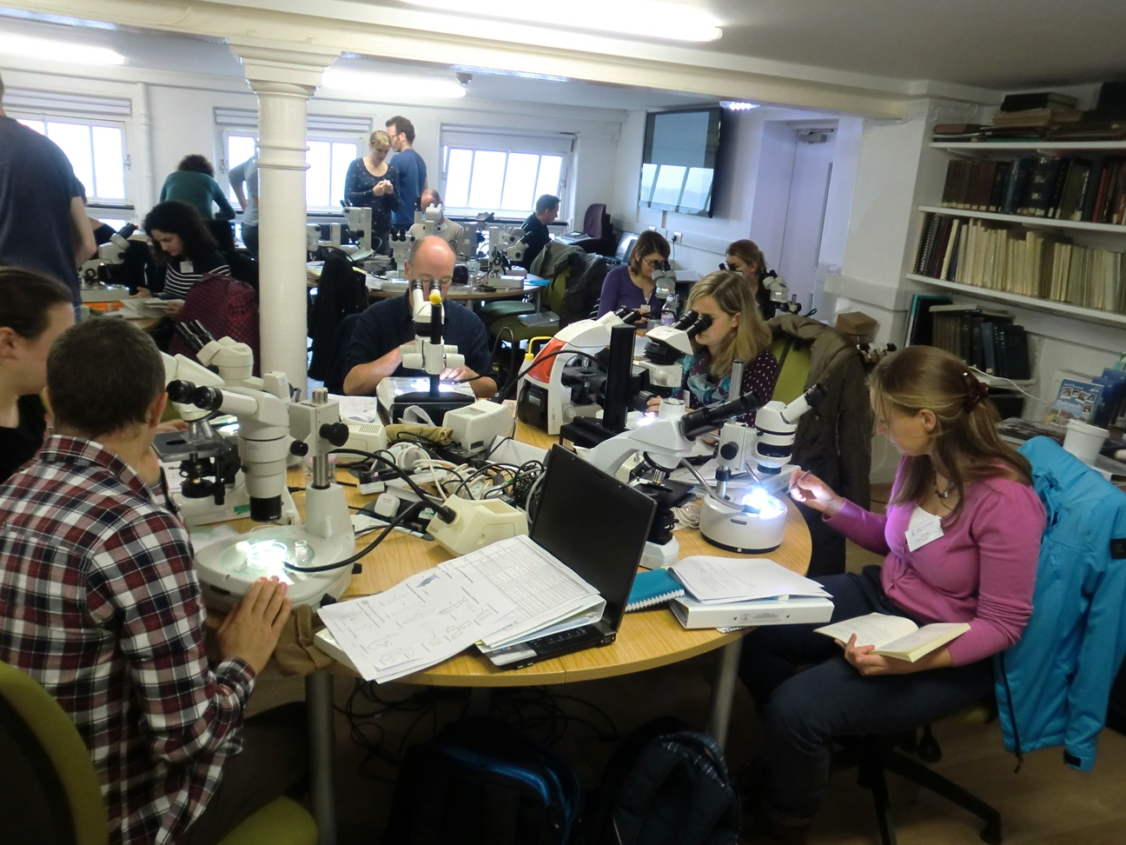
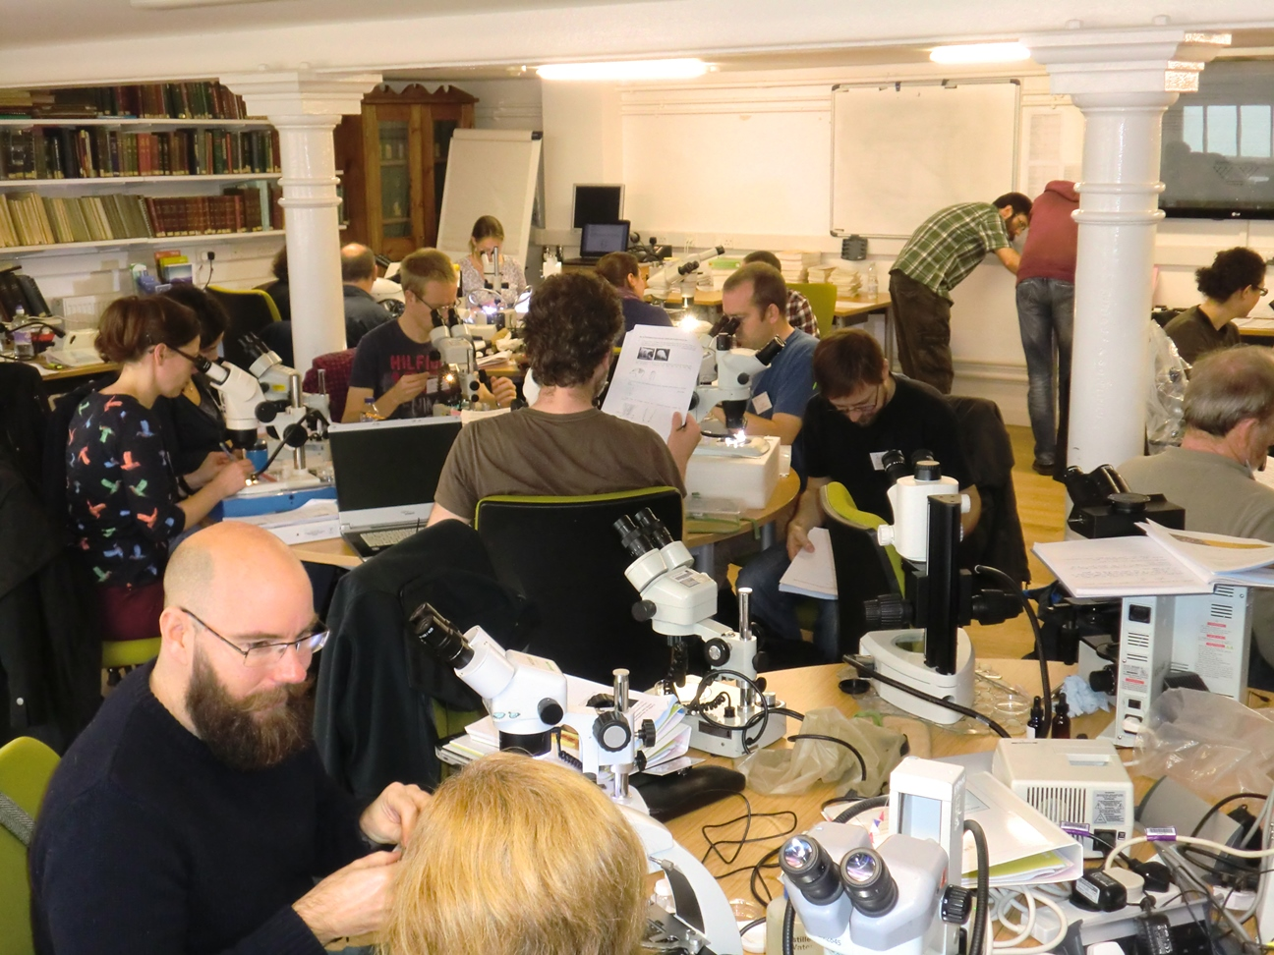
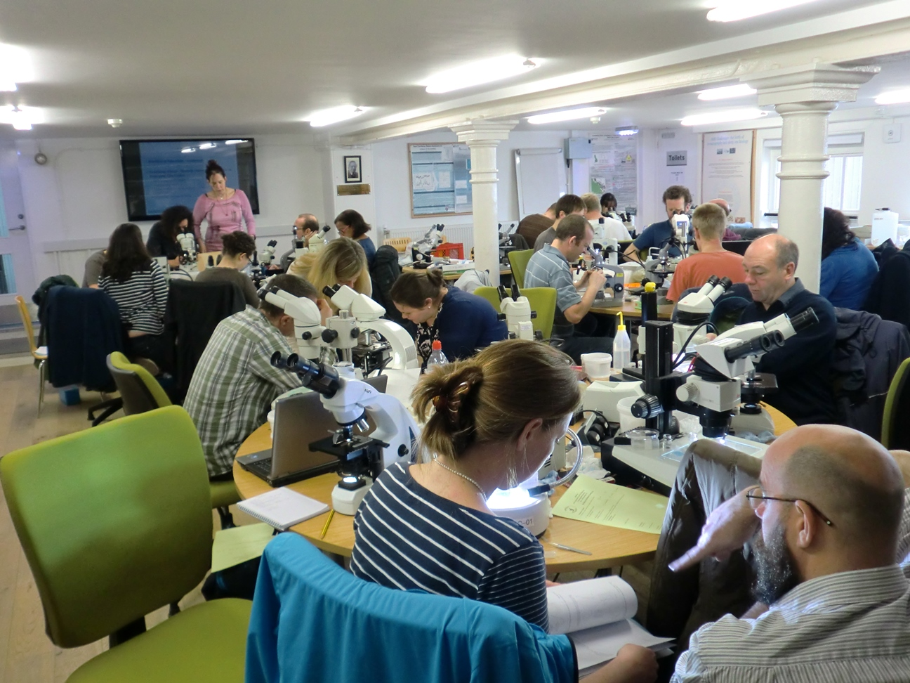
The official workshop participant photo which shows everyone who took part;
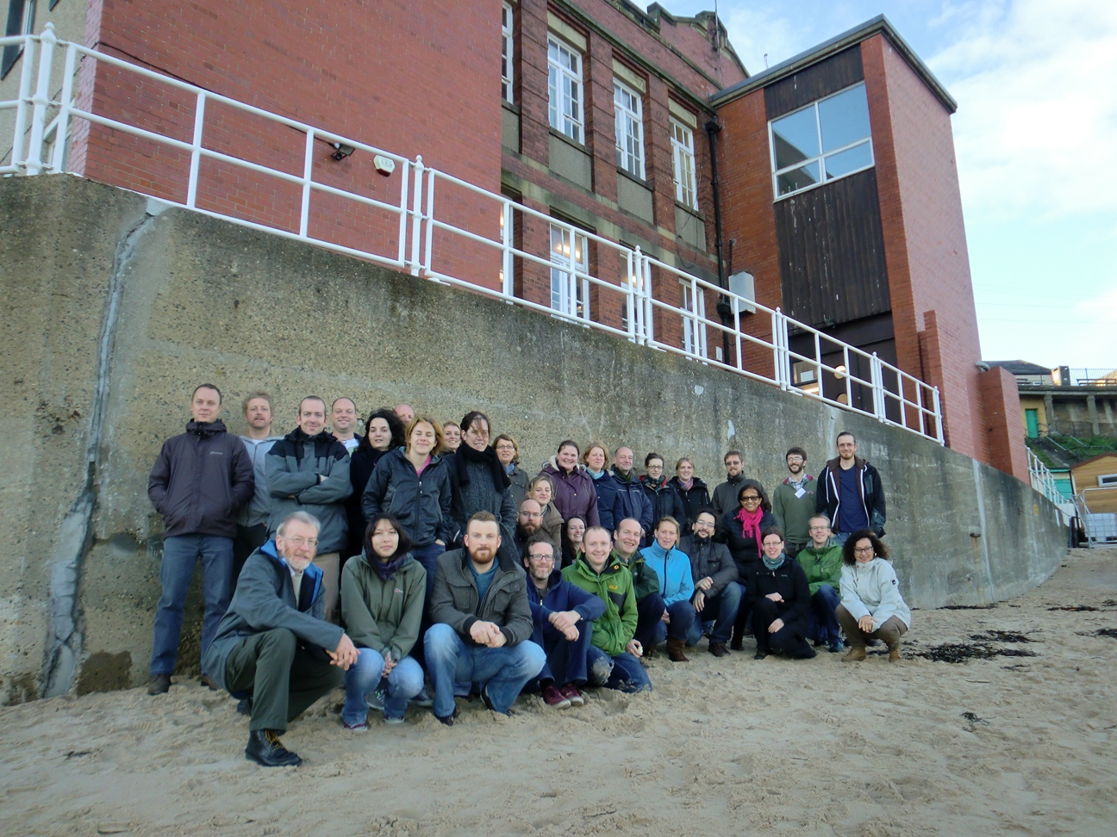

The University of Newcastle's Dove Marine Laboratory location and the beach it overlooks at Cullercoats on Tyneside;
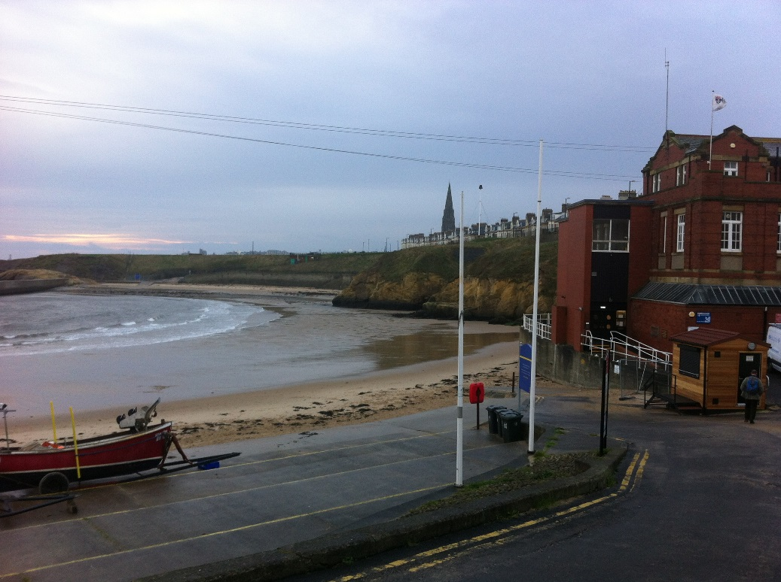
Two participants looking at specimens provided by the organisers and experts.
