

Particle Size Analysis Component Annual Report
Scheme Operation 2023/2024 (Year 30)

Authors: | Lydia McIntyre-Brown (APEM)  NMBAQCS Particle Size Analysis Administrators
Authors: | Prof. Kenneth Pye (KPAL), NMBAQCS Particle Size Benchmark Analyst
Reviewer: | David Hall (APEM), NMBAQCS Project Manager
Approved by: | Claire Mason (Cefas), Contract Manager
Contact: | nmbaqc@apemltd.co.uk
Date of Issue: | August2024


PARTICLE SIZE COMPONENT ANNUAL REPORT FROM APEM Ltd
Contents

1. Introduction 4
1.1 Assessing Performance 5
1.2 Statement of Performance 5
2. Summary of PSA Component 5
2.1 Introduction 5
2.2 Logistics 5
2.3 Data returns 6
2.4 Confidentiality 6
3. Particle Size Analysis (PS) Module 6
3.1 Description 6
3.1.1 Asbestos testing 6
3.1.2 Preparation of the Samples 6
3.1.3 Analysis required 7
3.2 Results 8
3.2.1 General comments 8
3.2.2 Analysis of sample replicates (Benchmark Data) 8
3.2.3 Results from participating laboratories 10
3.2.4 Discussion 19
3.2.5 Application of NMBAQC Scheme Standards and Laboratory Performance 23
4. Particle Size Own Sample Analysis (PS-OS) module 23
4.1 Description 23
4.1.1 Analysis required 24
4.2 Results 25
4.2.1 General comments 25
4.3 Discussion 30
5. Conclusions and Recommendations 32
6. References 34

SCHEME OPERATION – 2023/24 (Year 30)
Linked Documents (hyperlinked in this report):

Particle Size Exercise Results – PS88
Particle Size Exercise Results –PS89
Particle Size Exercise Results –PS90
Particle Size Exercise Results –PS91

List of Figures:
Figure 1. Particle size distribution curves for sediment distributed as PS88 (Figure 7 in PS88 Report). 11
Figure 2. Stacked column chart showing the percentage gravel, sand, silt, and clay for sediment distributed as PS88 (Figure 8 in PS88 Report). 12
Figure 3. Particle size distribution curves for sediment distributed as PS89. 14
Figure 4. Stacked column chart showing the percentage gravel, sand, silt, and clay for sediment distributed as PS89 (Figure 7 in PS89 Report). 14
Figure 5. Particle size distribution curves for sediment distributed as PS90 (Figure 6 in PS90). 16
Figure 6. Stacked column chart showing the percentage gravel, sand, silt, and clay for sediment distributed as PS90 (Figure 7 in PS90 Report). 17
Figure 7. Particle size distribution curves for sediment distributed as PS87 (Figure 7 in PS91 Report). 18
Figure 8. Stacked column chart showing the percentage gravel, sand, silt, and clay for sediment distributed as PS91 (Figure 8 in PS91 Report). 19
Figure 9. Bar charts showing raw sieve data as percentages in each half-phi interval for PS88 (top), PS89 (middle) and PS91 (bottom). 20
Figure 10. Differential final laser data provided by participants for exercises PS88 (top left), PS89 (top right), PS90 (bottom left) and PS91 (bottom right). 22
Figure 11. Bar charts showing percentage gravel, sand, silt, and clay in the PS-OS module from laboratories PSA_3003, PSA_3004, PSA_3005 and PSA_3006. 28
Figure 12. Bar charts showing percentage gravel, sand, silt, and clay in the PS-OS module from laboratories PSA_3010, PSA_3011, PSA_3012 and PSA_3020. 29
Figure 13. Bar charts showing percentage gravel, sand, silt, and clay in the PS-OS module from laboratory PSA_3021. 30

List of Tables
Table 1. Summary data for original and re-submitted results for PSA_3015 for PS89. 14
Table 2. Summary data for original and re-submitted results for PSA_3011 and PSA_3008 for PS90. 16
Table 2.Minimum, maximum and average percentage clay recorded for differing laser manufacturers for PS90. 17
Table 4. Summary data for original and re-submitted results for PSA_3011 for PS91. 18
Table 5. Gradistat sediment descriptions from the primary data and the AQC re-analysis. Taken from Table 5 of the individual PS-OS reports. 27

Abbreviations
NMBAQC – National Marine Biological Analytical Quality Control
PSA – Particle Size Analysis
PS – Particle Size
PS-OS – Particle Size Own Sample
CMA – Competent Monitoring Authority
MPA – Marine Protected Area
CSEMP – Clean Seas Environmental Monitoring Programme
MSFD – Marine Strategy Framework Directive
WFD – Water Framework Directive
RSMP – Regional Seabed Monitoring Plan
SoP – Statement of Performance
BC – Beckman Coulter
MM – Malvern Mastersizer

Introduction
The NE Atlantic Marine Biological Analytical Quality Control (NMBAQC) scheme is a quality assurance scheme developed on behalf of the UK competent monitoring authorities (CMAs). Its principal aim is to provide assessment of marine biological data contributing to UK national or European monitoring programmes.
The scheme also aims to develop and promote best practice in relation to sampling and analysis procedures through a range of training exercises, workshops, and literature guides.
The scheme includes seven biological components, each with its own set of training exercises and/or assessment modules.
APEM Ltd has been the administrative contractor for the Particle Size component since 2014 (Scheme year 21).
The Particle Size (PS) component of the scheme comprises two modules:
- The PS Ring Test (PS)
- The PS – Own Sample (PS-OS)
The PS module followed the same format as 2022/23; a series of exercises involved the distribution of test materials to participating laboratories and the centralised examination of returned data and samples.
The PS-OS module, introduced in the 2014/15 Scheme year, followed the same logistical format as the previous year. Selected participant samples are re-analysed by the NMBAQC Scheme PSA contractor, and the results are compared. The Particle Size Own Sample module is a training/audit module, and the purpose of this module is to examine the accuracy of particle size analysis for participants’ in-house samples.
Fifteen laboratories signed up to participate in the 2023/24 PS module exercises (PS88, PS89, PS90 and PS91); six were government laboratories and nine were private consultancies. Nine laboratories signed up to participate in the PS-OS module exercises (PS-OS28, PS-OS29 and PS-OS30); four were government laboratories and five were private consultancies.
To reduce potential errors and simplify administration, Lab Codes were assigned with a prefix to determine the Scheme component; all codes for the Particle Size component were prefixed with “PSA_”.
As in previous years, some laboratories elected to be involved in limited aspects of the Scheme. Competent monitoring authorities (CMAs) completing PSA in support of biological analysis for monitoring programmes (including in assessment of MPA (Marine Protected Areas), as evidence under MSFD (Marine strategy framework directive) and WFD (Water Framework Directive), as well as the CSEMP (Clean Seas Environmental Monitoring programme), must participate in this component of the Scheme. The Scheme is aware of other PSA methodologies (e.g. those used in the Regional Seabed Monitoring Plan) and encourages those involved in any relevant PSA monitoring programmes to participate in this Scheme, especially where pass/fail criteria can be used to assess overlapping aspects of different methodologies.

Assessing Performance
For 2023/24 (Scheme Year 30) both the PS and PS-OS reports followed a similar format, with each sample analysis section broken down for review, including sieve processing, laser processing and final data. Laboratories received a “Good” or “Review” flag based on their results; “Review” flags had accompanying comments as to where errors have been made and how to correct them. Review flags could be upgraded to “GOOD – following remedial action” provided the participant supplied evidence of completing required actions or re-submitted results within a month of the issue of the interim report.

Statement of Performance
Each participating laboratory received a copy of the interim results for each exercise; these included a summary of results provided by each laboratory and a basic discussion of any major outliers. Once any remedial actions, re-submissions and minor data changes were completed by participants a final version of each report was made available on the Scheme website. Further details and analysis can be found in this report.
At the end of the Scheme year each laboratory received a ‘Statement of Performance’ document (SoP), which included a summary of results for each of the Scheme’s modules and details the resulting flags where appropriate. These statements were first circulated with the 1998/1999 annual report for the purpose of providing proof of Scheme participation and for ease of comparing year on year progress.

Summary of PSA Component

Introduction
The two 2023/24 year PSA modules, PS and PS-OS are described in more detail below. A brief outline of the information obtained from the module is given, together with a description of the preparation of the necessary materials and brief details of the processing instructions given to each of the participating laboratories.

Logistics
The labelling and distribution procedures employed previously have been maintained and specific details can be found in the Scheme’s annual reports for 1994/95 and 1995/96 (Unicomarine, 1995 & 1996). Email was the primary means of communication for all participating laboratories. This has considerably reduced the amount of paper required for the administration of the Scheme.

Data returns
Spreadsheet based workbooks for each circulation were distributed to participating laboratories via email and data returned to APEM Ltd via the NMBAQC Scheme email address. In this and previous Scheme years slow or missing returns for exercises lead to delays in processing the data and resulted in difficulties with reporting and rapid feedback of results to laboratories. Reminders were distributed shortly before each exercise deadline.

Confidentiality
To preserve the confidentiality of participating laboratories, each was identified by a four-digit Laboratory Code prefixed with “PSA_”, to identify the scheme component. In October 2023 each participant was given a confidential, randomly assigned 2023/24 (Scheme year thirty) Lab Code. Codes are prefixed with the Scheme year to reduce the possibility of obsolete codes being used inadvertently by laboratories, e.g. Laboratory number twelve in Scheme year thirty (2023/24) was recorded as PSA_3012.

Particle Size Analysis (PS) Module

Description
This component examined the percentage of sediment found in each half-phi interval from the particle size analysis of replicate sediment samples. Four samples of sediment, one fine (PS90), one mixed (PS91) and two coarse (PS88 and PS89) were distributed in 2023/24. The samples were distributed in two stages; the first circulation (PS88 and PS89) was sent to participants on 1st December 2023 and the second circulation (PS90 and PS91) was sent on the 1st March 2024. For each circulation participants were given approximately 6 weeks to complete their analysis and send completed workbooks via email to APEM Ltd. PS88, PS90 and PS91 were derived from natural marine sediments; PS89 replicates were prepared from a mixture of natural sediment and artificially prepared commercial sand and aggregates; they were prepared at APEM’s Letchworth laboratory as described below.

Asbestos testing
Following participant concerns raised during Scheme Year 25 (2018/2019) about the possible presence of asbestos in natural sediments used to create the PS exercises, all the natural sediments are now sent for asbestos testing prior to the creation of the samples. Sediments are only used when they have tested negative for asbestos; any that test positive are disposed of either in a landfill that has a specific permit authorising it to accept asbestos or in a non-hazardous waste landfill, provided it is self-contained. Details and results of asbestos testing can be requested by emailing APEM’s NMBAQC email address.

Preparation of the Samples
The first PS circulation, PS88, was a Sandy Gravel created using 300g of Sand from the Wash, pre-sieved over a 1mm sieve to remove any larger particles. This was mixed with known quantities of gravel from around 75km northeast of Fraserburgh off the Aberdeenshire coast which had been split into half-phi intervals by dry sieving using a mechanical sieve shaker
The second exercise, PS89, was a Sandy Gravel created from known amounts of commercially acquired tropical reef aquarium gravel and coarse sand from the West of Orkney (split into half-phi intervals by dry sieving using a mechanical sieve shaker) mixed with commercially acquired builders sand which had been pre-sieved through a 1mm sieve to remove any larger particles or debris that may have been present.
The third exercise, PS90, was created from natural sediment from the river Orwell, Suffolk. Approximately 10 litres of visually similar sediment were collected and returned to the laboratory where it was wet sieved at 1.0mm to remove any particles larger than 1.0mm. Sediment that passed through the 1.0mm sieve was retained in a large tray, mixed and left to settle; excess water was removed before it was cored into replicate samples of approximately 200 grams in weight.
The fourth replicate, PS91 was created using 100g of the mud from Orwell mixed with known quantities of >1mm sediment from 75km northeast off the Aberdeenshire coast and sandy material from the West of Orkney.
Five replicate samples from each of these exercises were sent to Kenneth Pye Associates Ltd (KPAL) for particle size analysis to assess the degree of inter-sample variation and to produce benchmark data. Where laser diffraction analysis was required, these replicates were analysed using a Beckman Coulter LS13320 laser diffraction instrument. The remaining replicates were randomly assigned to participating laboratories and distributed according to the Scheme timetable. Spare replicates were kept at the APEM Ltd. Letchworth laboratory in case of problems such as damaged samples during delivery or significant processing errors.

Analysis required
The participating laboratories were required to conduct particle size analysis on the samples following the NMBAQC Scheme’s best practice guidance for particle size analysis to support biological data (NMBAQC Best Practice Guidelines (Mason, 2022)), either in-house or using a subcontractor. A summary of the sample as a written description of the sediment characteristics was to be recorded, with a qualitative visual assessment made prior to processing, using the Folk (1954) textural classification. In addition, the percentages of gravel, sand and silt/clay and any use of peroxide treatment or chemical dispersant were to be noted. Also requested was a breakdown of the particle size distribution, expressed as a weight or volume percentage at half-phi () intervals, for each of the raw sieve data (>1mm), the raw laser data (<1mm) and the final merged dataset.
The 2023/24 workbooks followed the format of the updated 2022/23 workbooks to help enable the continuity of data through the workbook. All sieve and laser data are now entered into a single worksheet, with conditional formatting to flag up red cells to indicate possible data entry errors. Data provided in the “Laser Metadata” spreadsheet tab were for analytical purposes only and were not published in the Interim Results reports. Benchmark metadata were included in each sample report for participants to see how the Benchmark Lab analysed each sample.
Approximately nine weeks were allowed for the analysis of the first pair of PS samples sent out (PS88 & PS89) and approximately eight weeks for the second pair (PS90 & PS91).

Results

General comments
Fifteen laboratories subscribed to the exercises in 2023/24. For the first circulation (PS88 and PS89) twelve subscribing participants provided results on time. Participant PSA_3014 communicated that they would not be able to meet the February deadline but would submit data in March, despite reminders at the time of writing no results have been received. PSA_3009 communicated that they had recently relocated to new premises and were currently setting up the lab and awaiting UKAS accreditation, they would participate once they were fully operational. PSA_3013 did not submit data and did not provide any further communication indicating non-participation. PSA_3001 submitted three sets of laser results for PS88 and PS89 as they were in the process of testing a new laser analyser. For the second circulation (PS90 and PS91) nine participants provided results on time. PSA_3001, PSA_3010 and PSA_3015 requested an extension to the submission deadline. PSA_3009 communicated non-participation as per above. PSA_3001 submitted two laser results for PS90 and PS91 as they are in the process of testing a new laser analyser. PSA_3013 did not submit data and did not provide any further communication indicating non-participation. PSA_3014 communicated that results would be late however at the time of writing no data has been received.
Most participating laboratories now provide data in the requested format, although some variations remain. As reported previously, it should be remembered that the results presented may be from a more limited number of analytical laboratories than is immediately apparent since this component of the Scheme is often sub-contracted by participants to one of a limited number of specialist laboratories. Participant PSA_3001 submitted three sets of laser results for each sample to compare laser models and analysts. Before processing commenced it was agreed with the contract manager that up to three submissions per replicate sample could be made before a second replicate sample would have to be paid for.
Detailed results for each exercise (PS88, PS89, PS90 and PS91) have been reported to the participating laboratories; additional comments are provided below.

Analysis of sample replicates (Benchmark Data)
Five replicate samples of the sediment used for the four PS distributions were analysed by KPAL to examine variability and establish benchmark data that participant results can be compared with. Replicate samples supplied by APEM were analysed, where required, using Endecotts British Standard 300mm and 200mm test sieves, Endecotts EFL 2000/2 and Retsch AS2001 Control ‘g’ sieve shakers and a Beckman Coulter LS13320 laser size analyser. In previous Scheme years replicates were analysed by both laser diffraction and sieve/pipette methods; however, as all participating laboratories are now conducting less than 1mm analysis by laser diffraction the testing of replicates for 2023/24 was undertaken only using a laser diffraction instrument.
The analysis results for the benchmark replicates were assessed by APEM to analyse the variability between the replicates and to establish the reproducibility of the samples. The analysis showed an overview of the sample including percentage Gravel, Sand and Mud along with a description of the sediment using the textural group from a Gradistat (Blott & Pye, 2001) output of the final data, e.g. Slightly Gravelly Muddy Sand. The processing of the sample was split into sieve and laser analysis.
Sieve analysis is displayed in a table with the raw weight recorded in each half phi interval from -6.5 to 0.0phi and the weight of the less than 1mm oven dried sample plus any sediment from the base pan of the sieve shaker. The percentage weight in each half-phi category is also displayed graphically in a bar chart for visual comparison.
Laser analysis included a table of the final laser data for each replicate with Gradistat outputs along with a graph showing the differential and cumulative percentage. The triplicate analysis undertaken to obtain the final laser data was presented in a table in Appendix 1. For each replicate sample the Coefficient of Variation (CV) was calculated for the D₁₀, D₅₀ and D₉₀ particle size in microns. The CV is most commonly expressed as the standard deviation as a percentage of the mean and describes the dispersion of a variable in a way that does not depend on the variables’ measurement units. A low CV indicates a smaller amount of dispersion in the variable. BS ISO 13320 states that good laser reproducibility is shown for replicates when the %CV is <3% for the D₅₀ and <5% for the D₁₀ and D₉₀, all limits are doubled when the D₅₀ was less than 10µm. In reality 3% and 5% are low and greater variability is expected in natural sediment samples therefore a maximum of 20% will be used as guidance.
Benchmark analysis of the replicates for Sample PS88 indicated an average composition of 63.98% gravel, 33.63% sand and 2.39% mud, classified as ‘Sandy Gravel’ according to the Blott & Pye (2012) scheme. Analysis of the triplicate laser analysis for each replicate sample showed that the %CVs for the D₁₀, D₅₀ and D₉₀ were well within the acceptable limits and therefore the replicates were deemed to have good reproducibility. Results for the individual replicates are provided in Tables 1, 2, 3, 4 and 5, and are displayed in Figures 1, 2 and 3 in the PS88 Report.
Sample PS89 was a mixed sediment and contained an average of 46.04% gravel, 50.59% sand and 3.37% mud, classified as a ‘Sandy gravel’ according to the Blott & Pye (2012) scheme. The replicates were analysed by dry sieving and laser analysis. The sieve data shows consistent results between the replicates and triplicate laser analysis showed extremely low variation, with %CV well below acceptable levels for each statistic. Results for the individual replicates are provided in Tables 1, 2, 3, 4 and 5, and are displayed in Figures 1, 2 and 3 in the PS89 Report. Two of the Benchmark replicates were damaged in transit, one sample was replaced with a spare replicate, the second replaced sample had a different batch of <1mm material and although the laser outputs were the same the water content was different leading to a different weight of <1mm material. Therefore the average <1mm weight of the other four replicates was used to create the final data for the fifth replicate.
Sample PS90 was a fine sample and contained an average of 48.24% sand and 51.76% mud, classified as a ‘Sandy Mud’ according to the Blott & Pye (2012) scheme. The replicates were analysed by laser analysis only. The benchmark laboratory commented that one or two particles were retained on the 1mm sieve however these were insignificant and have been excluded from the final result. For reference three Benchmark replicates (PSA_3036, PSA_3037 and PSA_3040) retained 0.01g on the 1mm sieve. The triplicate laser analysis showed low variation, the %was below the acceptable levels for all statistics. Results for the individual replicates are provided in Tables 1, 2, 3, 4 and 5, and are displayed in Figures 1, 2 and 3 in the PS90 Report.
Sample PS91 was a mixed sediment sample containing an average of 43.51% gravel, 51.58% sand and 4.90% mud, classified as ‘Sandy Gravel’ according to the Blott & Pye (2012) scheme. Analysis of the triplicate laser analysis for each replicate sample showed that the %CVs for the D₁₀, D₅₀ and D₉₀ were well within the acceptable limits and therefore the replicates were deemed to have good reproducibility. Results for the individual replicates are provided in Tables 1, 2, 3, 4 and 5, and are displayed in Figures 1, 2 and 3 in the PS91 Report.

Results from participating laboratories
In each of the PS88, PS89, PS90 and PS91 reports, data provided by the participants are displayed in a series of tables and figures for comparison with each other and with the Benchmark Data. The Participant section provides three tables of data, the first outlining an overview of summary data including equipment and methodology used, the use of any chemical dispersants or pre-treatments, the percentage gravel, sand, and silt/clay recorded as well as the participants’ post-analysis sediment descriptions. The second table provides the raw sieve weights for each half-phi interval submitted by each participant including the less than 1mm weights for the sieve shaker base pan fraction and the wet-separated and oven dried fraction and in the third table the final laser data submitted by each participant is shown. Tables showing the results of the triplicate laser analysis supplied and the Coefficient of Variance of the D₁₀, D₅₀ and D₉₀ are available in Appendix 1. These tables are accompanied by a series of graphs and bar charts which allow the results to be visually compared. Appendix 2 shows the data used to create the percentage gravel, sand, silt, and clay bar-charts. The final merged data submitted by each participant and the benchmark laboratory are provided in Appendix 3. Where available a graphical comparison of individual sieve results are shown in Appendix 4.

Eighty-eighth distribution – PS88
Figures 1 and 2 show there was generally good agreement for PS88 between the results for the Benchmark replicates and those supplied by the participating laboratories. None of the participants re-submitted or adjusted their data after the issue of the Interim Report.
The summary data (Table 6 in the exercise report) showed that none of the participants used chemical dispersants or peroxide pre-treatments. All participants recorded a Gradistat textural group of ‘Sandy Gravel’. Percentage gravel ranged from 58.78% (PSA_3008) to 68.50% (PSA_3007) with an average of 64.93%. Percentage sand ranged from 30.39% (PSA_3007) to 39.62% (PSA_3008) with an average of 33.43% and the percentage of mud ranged from 0.40% (PSA_3004) to 2.70% (PSA_3003) with an average of 1.63%.
All but two laboratories (PSA_3002 and PSA_3007) followed the NMBAQC methodology. Those that followed differing methodologies did not provide any details on how their methodology differed from the NMBAQC method. All participants analysed the sample using both sieve and laser analysis. PSA_3007 only sieve at 1-phi intervals above 1mm. Therefore, they are not assessed on the sieve aspect of the module. The average weight of participant material greater than 1.0mm was 703.87g and weight of less than 1.0mm was 296.21g compared to Benchmark results of 705.24g (>1.0mm) and 303.21g (<1.0mm). PSA_3008 recorded 223.87g less in the greater than 1.0mm fraction compared to the Benchmark lab which has caused them to record a reduced percentage of gravel compared to other participants but has not affected their description of the sample as Sandy Gravel.
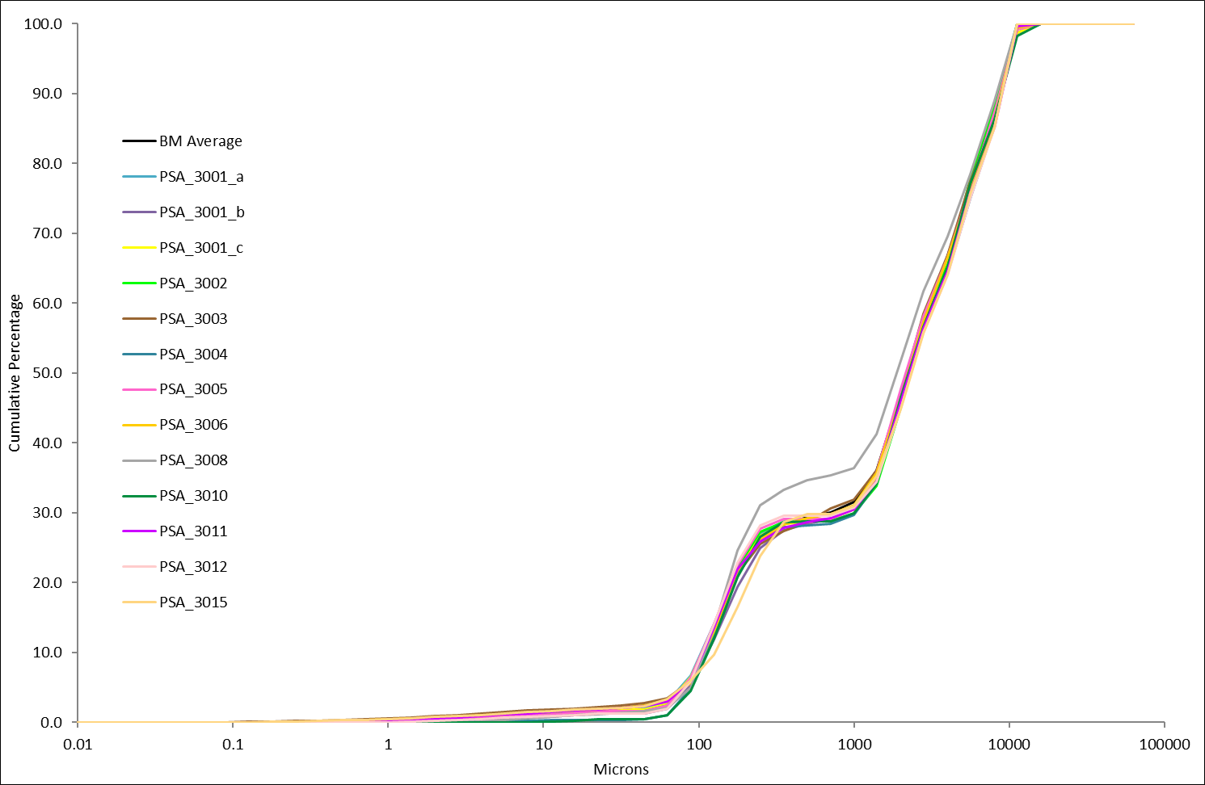
Figure 1. Particle size distribution curves for sediment distributed as PS88 (Figure 7 in PS88 Report).
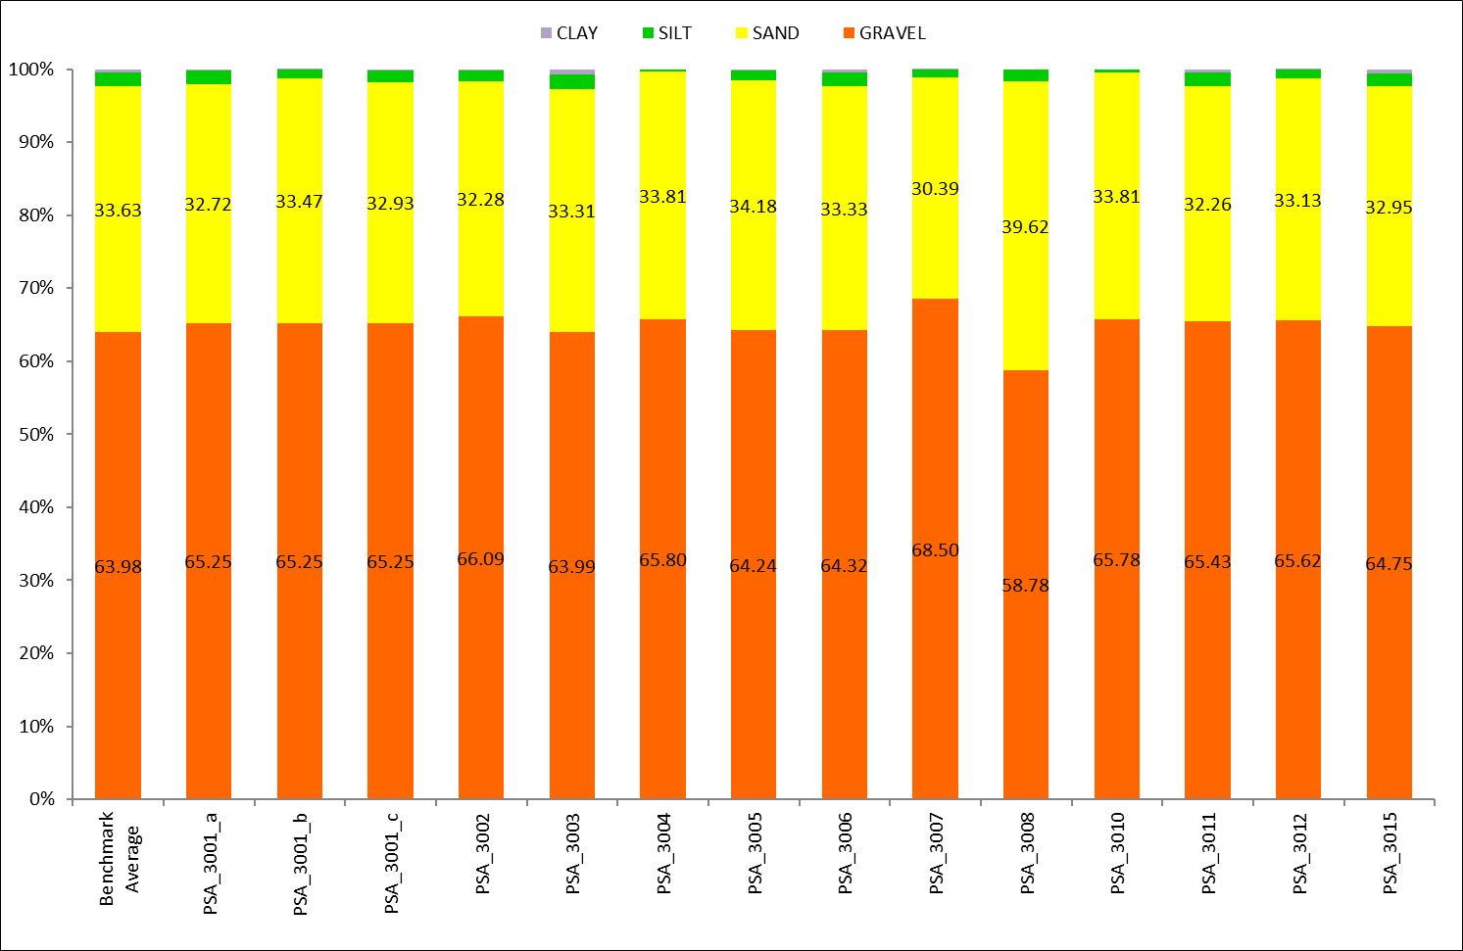
Figure 2. Stacked column chart showing the percentage gravel, sand, silt, and clay for sediment distributed as PS88 (Figure 8 in PS88 Report).

Laser data showed some variation in the amount of clay recorded in relation to the model of laser analyser used although the samples contained very small percentages of clay. Those participants using Beckman Coulter instruments (PSA_3003, PSA_3006, PSA_3011 and the Benchmark Lab) recorded an average percentage clay of 0.54% compared to an average of 0.10% for those using Malvern Mastersizer instruments. The Beckman Coulter LS13320 which uses a PIDS (Polarization Intensity Diffraction Scattering) system at the finer end, rather than diffraction, so provides better sensitivity than the Malvern system which employs diffraction of two different wavelengths of light (red and blue). Participant PSA_3015 is the only laboratory to use a Fritsch laser analyser, which recorded an amount of clay consistent with laboratories using the Beckman Coulter instruments. The Benchmark lab and the majority of participants recorded a unimodal laser distribution with the mode at 213.4µm, participant PSA_3015 recorded a unimodal distribution with the mode at 301.8µm.

Eighty-ninth distribution – PS89
There was good agreement for PS89 between the results from the analysis of the benchmark replicates and those from the participating laboratories (see Figures 3 and 4). Participant PSA_3015 was asked to review their laser result after the Interim Report due to an elevated percentage mud. Table 1 shows the original and re-submitted summary data for PSA_3015 with the Benchmark average for comparison.

Table 1. Summary data for original and re-submitted results for PSA_3015 for PS89.
Participant | Percentage |  |  | Sediment Description
Participant | Gravel | Sand | Mud | Sediment Description
Benchmark Average | 46.04 | 50.59 | 3.37 | Sandy Gravel
PSA_3015 Original | 47.36 | 32.68 | 19.96 | Muddy Sandy Gravel
PSA_3015 Re-submitted | 47.36 | 51.14 | 1.50 | Sandy Gravel

Following this re-submission all participants had a Gradistat textural group of ‘Sandy Gravel’. Percentage gravel ranged from 45.17% (PSA_3012) to 49.39% (PSA_3001) with an average of 47.12%. Percentage sand ranged from 48.18% (PSA_3001_c) to 54.30% (PSA_3008) with an average of 50.87% and the percentage of mud ranged from 0.06% (PSA_3008) to 3.75% (PSA_3002) with an average of 2.01%.
All but two laboratories (PSA_3002 and PSA_3007) followed the NMBAQC methodology. Those that followed differing methodologies did not provide any details on how their methodology differed from the NMBAQC method. All participants analysed the sample using both sieve and laser analysis. PSA_3007 only sieve at 1-phi intervals above 1mm. Therefore, they are not assessed on the sieve aspect of the module.
The average weight of participant material greater than 1.0mm was 341.68g and the average weight of less than 1.0mm was 241.20g compared to Benchmark results of 345.13g (>1.0mm) and 256.67g (<1.0mm). All participants and the Benchmark lab produced a unimodal laser distribution. Those using the Beckman Coulter LS 13320 and the Malvern Mastersizer 2000 recorded the mode at 426.8µm, whereas those using the Malvern Mastersizer 3000 recorded the mode at 301.8µm. The Fritsch Analysette 22 recorded the mode higher at 603.5µm.

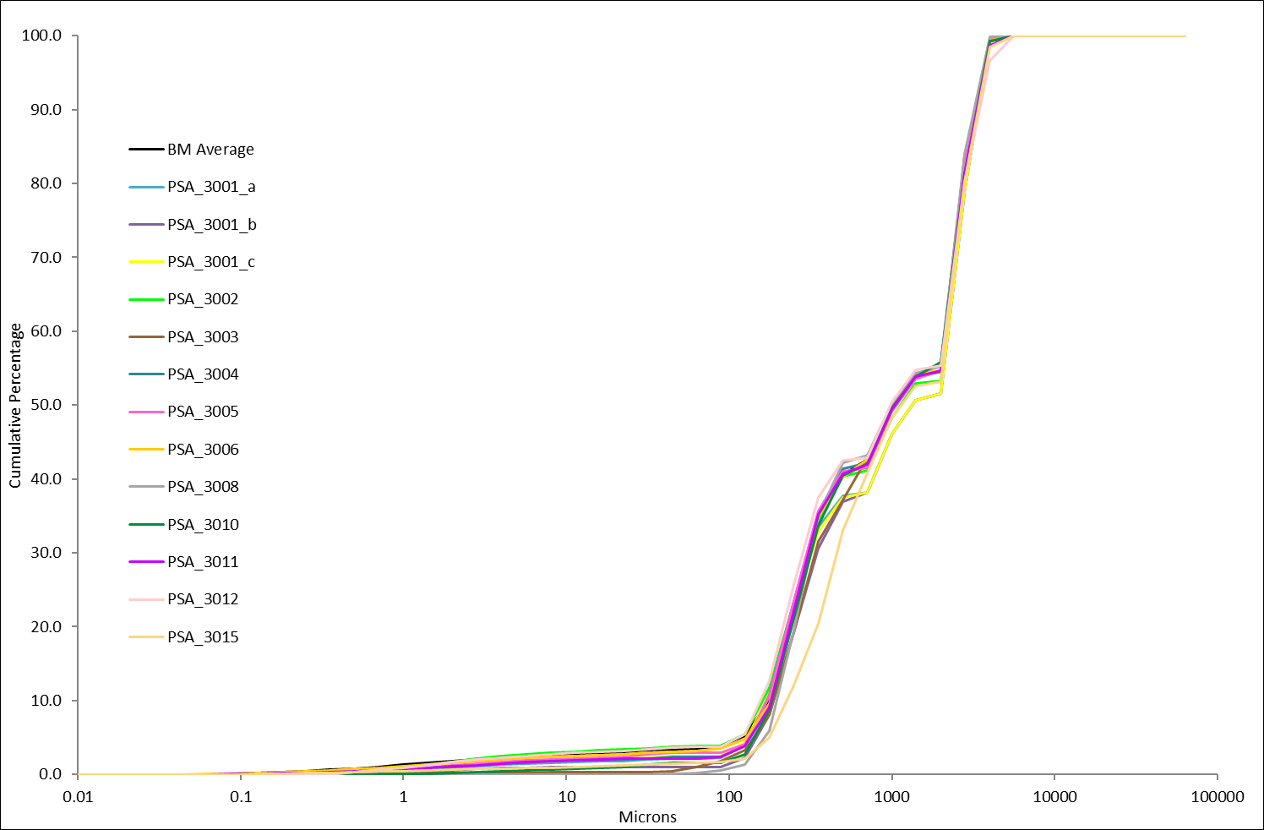
Figure 3. Particle size distribution curves for sediment distributed as PS89.
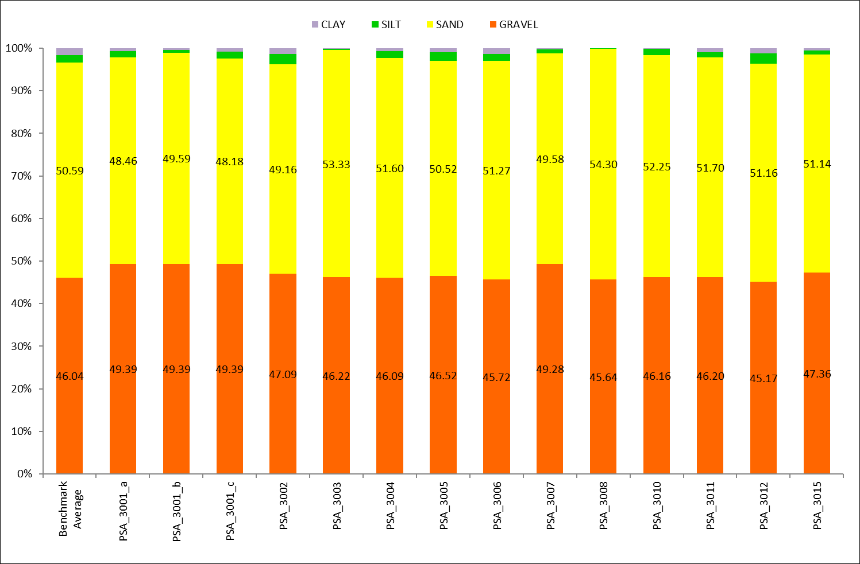
Figure 4. Stacked column chart showing the percentage gravel, sand, silt, and clay for sediment distributed as PS89 (Figure 7 in PS89 Report).

Ninetieth distribution – PS90
As Figures 5 and 6 show there was quite a lot of variation between the results reported by the participating laboratories and those obtained for the benchmark replicates for PS90. This sample was created using natural sediment and although there was a concerted effort to homogenise the bulk material it is expected that there would be more variation between participant results. Two participant (PSA_3008 and PSA_3011) re-submitted improved data following the issue of the interim report. Participant PSA_3010 received a review flag for the laser analysis but were yet to re-submit data at the time of writing.
Table 2. Summary data for original and re-submitted results for PSA_3011 and PSA_3008 for PS90.
Participant | Percentage |  |  | Sediment Description
Participant | Gravel | Sand | Mud | Sediment Description
Benchmark Average | 0.00 | 48.24 | 51.76 | Sandy Mud
PSA_3008 Original | 0.00 | 32.12 | 67.88 | Sandy Mud
PSA_3008 Re-submitted | 0.00 | 51.56 | 48.44 | Sandy Mud
PSA_3011 Original | 0.00 | 35.37 | 64.63 | Sandy Mud
PSA_3011 Re-submitted | 0.00 | 48.90 | 51.10 | Sandy Mud
Five participants (PSA_3001_a_b, PSA_3003, PSA_3004 and PSA_3015) recorded a Gradistat textural group of ‘Muddy Sand’ and seven participants recorded a Gradistat textural group of ‘Sandy Mud’.’ One participant had slightly higher gravel content and recorded the sample as ‘Slightly Gravelly Muddy Sand’. Other than PSA_3010, all participants recorded 0.00% gravel, PSA_3010 recorded 0.03% gravel. Sand composition ranged from 41.11% (PSA_3002) to 64.51% (PSA_3010) with an average of 50.32%. Mud composition ranged from a minimum of 35.46% (PSA_3010) to a maximum of 58.89 (PSA_3002) with an average of 49.68%.
Five participants (PSA_3001, PSA_3003, PSA_3004, PSA_3010 and PSA_3012) undertook both sieve and laser analysis, the remaining participants only undertook laser analysis. The Benchmark lab commented that one or two particles were retained on the 1.0mm sieve however these have been excluded from the final results; three Benchmark replicates (Rep 1, Rep2 and Rep 5) retained 0.01g on the 1.0mm sieve. Of the participants that undertook sieve analysis only very small weights of greater than 1.0mm material were detected; 0.01g (PSA_3001, PSA_3003, PSA_3012), 0.02g (PSA_3004) and the highest weight recorded was 0.17g (PSA_3010).
All participants (PSA_3003, PSA_3006 and PSA_3011) who used the Beckman Coulter LS 13320 instruments produced a trimodal laser distribution with the primary mode at 213.4µm and a secondary mode at 6.67µm. the third mode was at 26.67µm for participants PSA_3003 and PSA_3011, and at 37.72µm for participant PSA_3006. The participants using the Malvern Mastersizer 2000 or 3000 generally produced bimodal laser distributions with the primary mode at either 213.4µm or 301.80µm, and the secondary mode was at 6.67µm. The Fritsch Analysette produced a trimodal distribution like the Beckman Coulter
The sample showed some variation in the amount of clay recorded in relation to the model of laser analyser used. Those participants using Beckman Coulter instruments (PSA_3003, PSA_3006, PSA_3011 and the Benchmark Lab) recorded an average percentage clay of 9.05% which was higher than those using Malvern Mastersizer instruments which had an average of 4.75% clay. The Beckman Coulter LS13320 which uses a PIDS (Polarization Intensity Diffraction Scattering) system at the finer end, rather than diffraction, so provides better sensitivity than the Malvern system which employs diffraction of two different wavelengths of light (red and blue). Participant PSA_3015 are the only laboratory to use a Fritsch laser analyser, which recorded an amount of clay consistent with laboratories using the Beckman Coulter instruments.
Table 2.Minimum, maximum and average percentage clay recorded for differing laser manufacturers for PS90.
 | Beckman Coulter  LS 13320 | Malvern Mastersizer 2000 or 3000 | Fritsch Analysette 22
Minimum | 8.87% | 3.04% | -
Maximum | 9.26% | 6.22% | -
Average | 9.05% | 4.75% | 8.01%

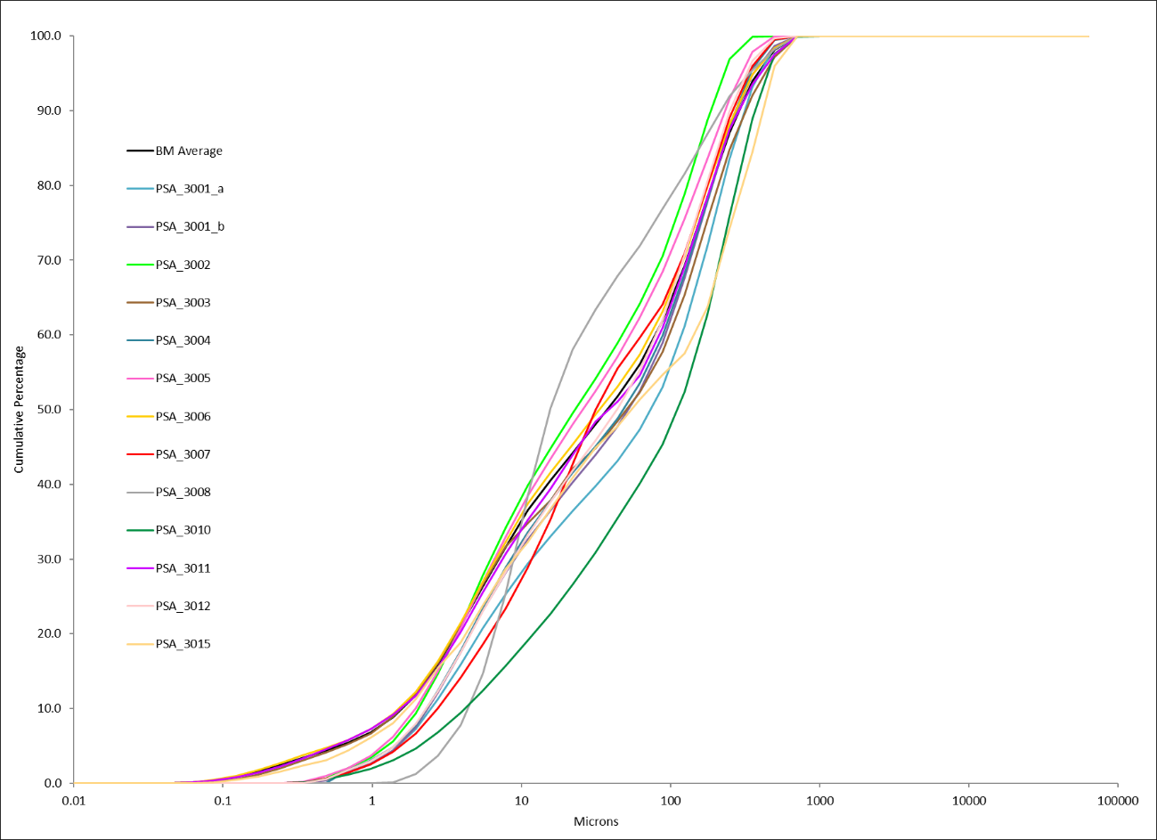
Figure 5. Particle size distribution curves for sediment distributed as PS90 (Figure 6 in PS90).
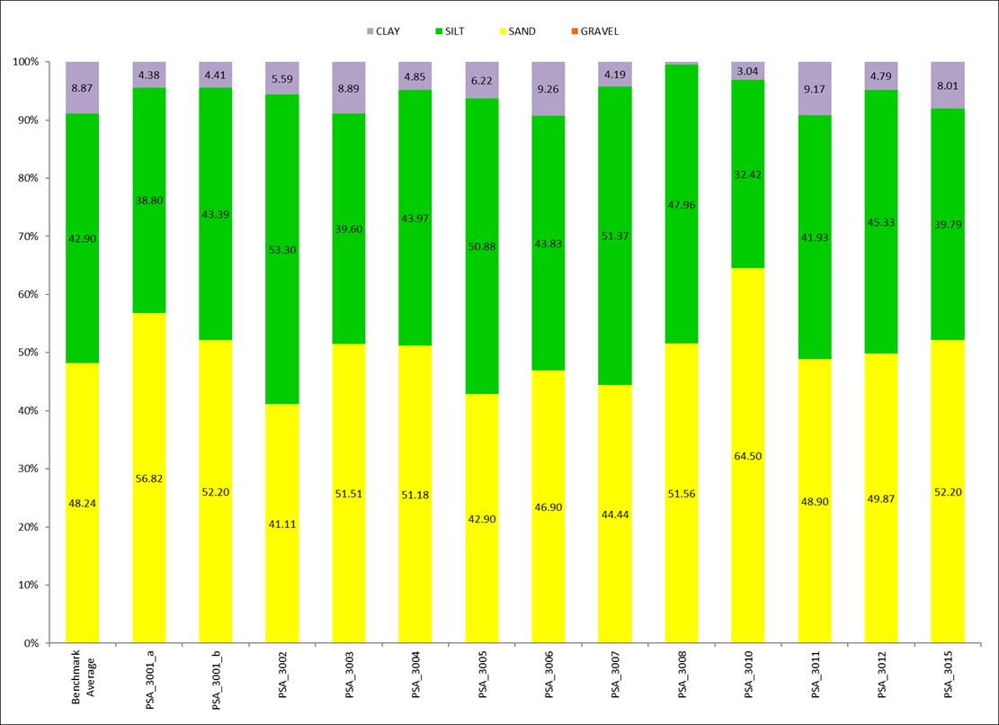
Figure 6. Stacked column chart showing the percentage gravel, sand, silt, and clay for sediment distributed as PS90 (Figure 7 in PS90 Report).

Ninety-first distribution – PS91
There was generally good agreement in results between the laboratories and the benchmark data (see Figure 7). PSA_3001 submitted two sets of laser data as they were trialling a new laser analyser; PSA_3001_a was undertaken using a Malvern Mastersizer 2000 and PSA_3001_b was undertaken using a Malvern Mastersizer 3000. Participant PSA_3011 re-submitted results following the issue of the interim report.
Table 4. Summary data for original and re-submitted results for PSA_3011 for PS91.
Participant | Percentage |  |  | Sediment Description
Participant | Gravel | Sand | Mud | Sediment Description
Benchmark Average | 43.51 | 51.58 | 4.90 | Sandy Gravel
PSA_3011 Original | 43.11 | 35.21 | 21.68 | Muddy Sandy Gravel
PSA_3011 Re-submitted | 43.11 | 50.85 | 6.04 | Muddy Sandy Gravel

Eight participants had a Gradistat textural group of ‘Sandy Gravel’ and five participants had a Gradistat textural group of ‘Muddy Sandy Gravel’. Percentage Gravel ranged from 42.30% (PSA_3006) to 50.08% (PSA_3010) with an average of 44.42%. The percentage of sand ranged from 45.07% (PSA_3015) to 52.85% (PSA_3006) with ab average of 44.42%. The percentage mud ranged from 1.62% (PSA_3007) to 11.00% (PSA_3015) and the average was 5.38%.
The majority of participants produced a unimodal laser distribution with the primary mode at 853.5µm. One participant (PSA_3015) produced a bimodal laser distribution, the primary mode was the same as other participants at 853.5µm however an additional mode was present at 9.4µm.
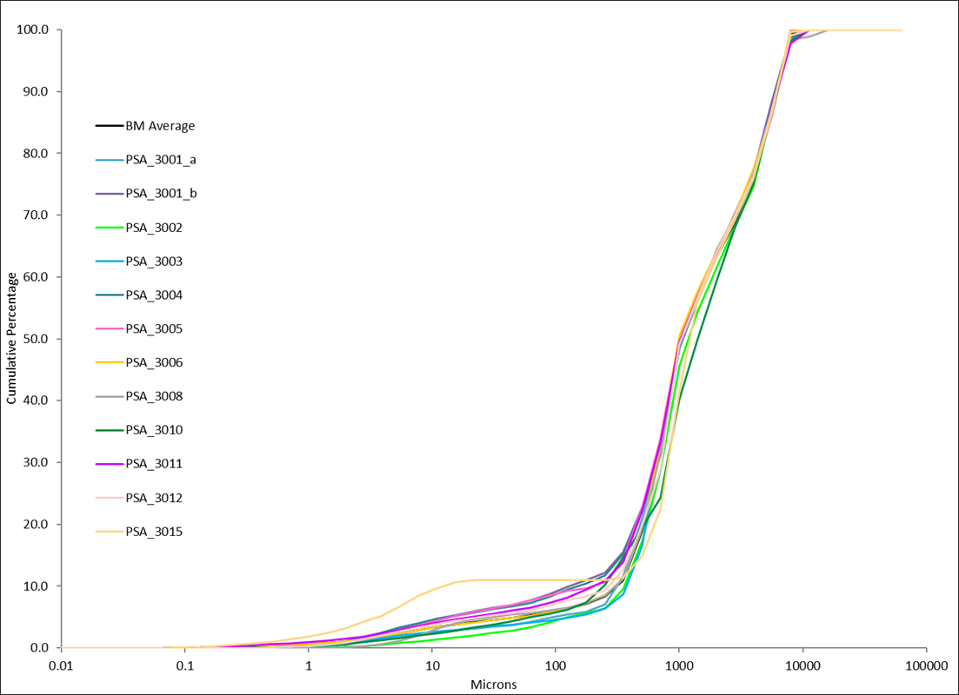
Figure 7. Particle size distribution curves for sediment distributed as PS87 (Figure 7 in PS91 Report).

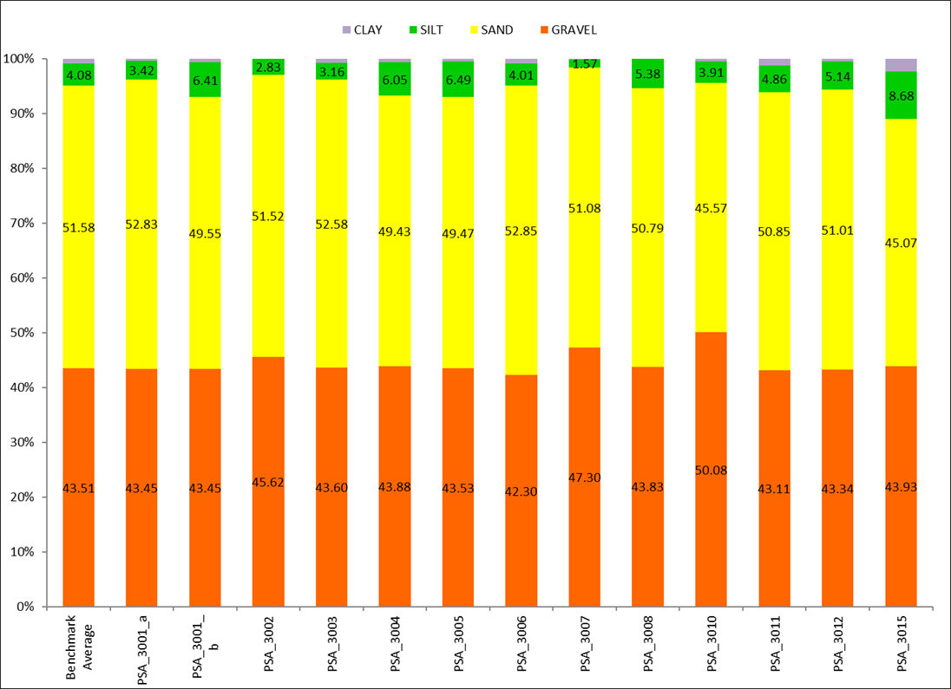
Figure 8. Stacked column chart showing the percentage gravel, sand, silt, and clay for sediment distributed as PS91 (Figure 8 in PS91 Report).

Discussion
The exercise reports show that most participants follow the NMBAQC methodology for these exercises, those that followed a different methodology (PSA_3002, PSA_3007) did not provide details on how their methodology differed from that of the NMABQC. PSA_3007 only process sediment greater than 1.0mm at one-phi intervals and are therefore not directly comparable with other participants or the Benchmark lab.

Sieve Analysis (>1mm)
The three exercises that contained larger quantities of sediment greater than 1mm (PS88, PS89 and PS91) show that the dry sieve analysis (>1mm) undertaken by participants was generally in agreement with each other and the benchmark data (see Figure 9). There is some variation, but this is to be expected with varying sieve times and amplitudes. The benchmark lab recorded a sieve time of 10mins and amplitude of 1.5mm/’g’. Of the sieve metadata provided by participants, sieve time varies from 2 to 30 minutes; sieve amplitude often didn’t include a unit of measurement. Units of measurement may vary due to differing brands of sieve shaker. Sediment type may also be a contributing factor, brittle or chalky material may break up more easily and the longer and more vigorously the sample is shaken the greater the effect will be on the sample.
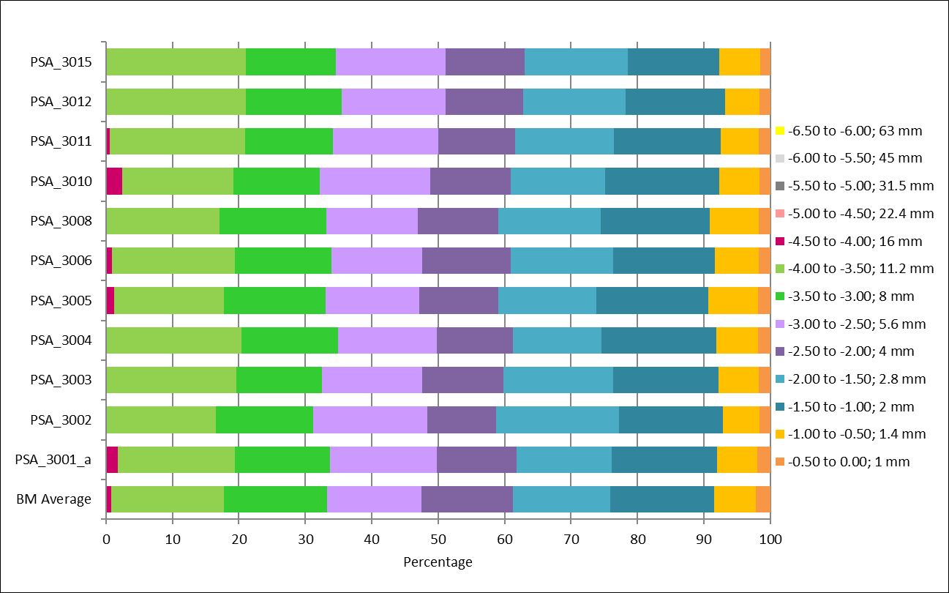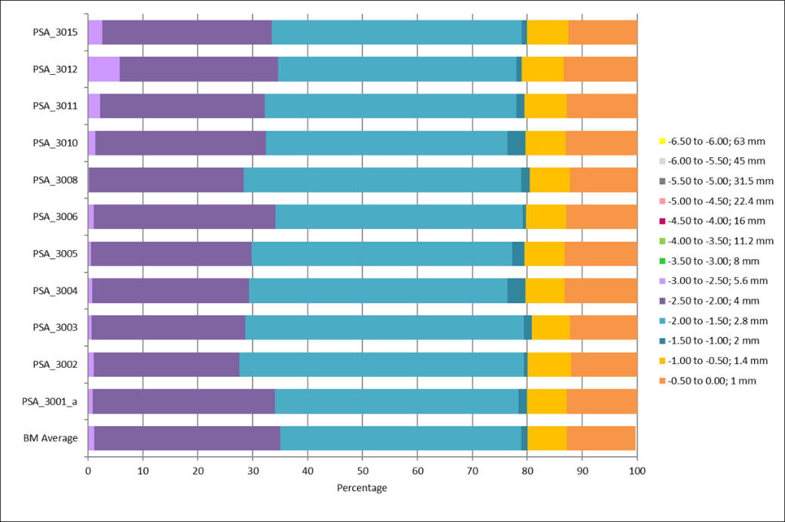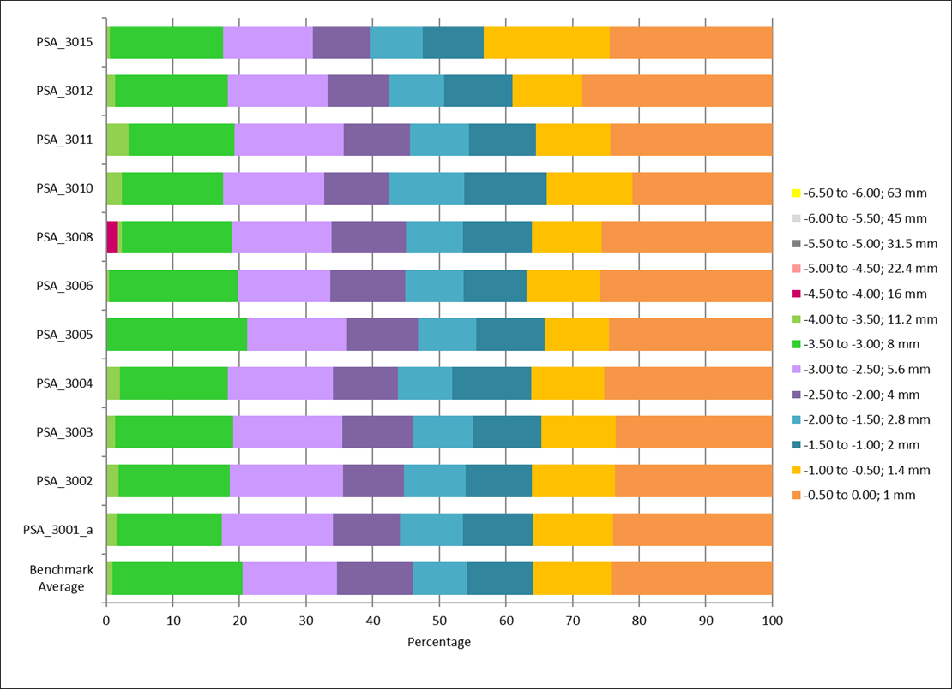
Figure 9. Bar charts showing raw sieve data as percentages in each half-phi interval for PS88 (top), PS89 (middle) and PS91 (bottom).

Laser Analysis (<1mm)
Figure 10 shows the differential curves for the laser data for each exercise. Although the results continue to show improvement from previous years, laser analysis remains the main source of variability between participants. All participants re-scaled their laser data to 100% before merging with the sieve data; where the final laser data provided included sediment >1mm, data were re-scaled to include only the <1mm fractions for comparisons with benchmark and other participant data.
As in previous years it was apparent in the exercises that required laser analysis and had a significant mud fraction (PS90) that there were some differences in results depending on which laser instrument was being used. The participants using the Beckman Coulter and Fritsch instruments recorded on average approximately 5% more clay than those using Malvern instruments (see Table 2). The Beckman Coulter instruments have greater measurement sensitivity and along with the Fritsch analyser were the only instruments capable of detecting particles below 0.345µm. The results obtained using the Beckman Coulter instruments also showed a much greater degree of similarity to each other than those using generated using the Malvern instruments. However, there were still slight differences detected between the participants using Coulter instruments, which could be due to differences in the samples supplied to each lab, different sub-sampling, sample dispersion and/or sample presentation procedures being used.
These differences between laser manufacturers were taken into consideration when comparing participant data with the Benchmark data especially where participants used the Malvern analysers as the Benchmark data is created using a Beckman Coulter.
Laser metadata are very important in helping to identify where possible mistakes are made and whether it is an issue with the laser or a sample preparation problem. For this reason, provision of metadata is a compulsory requirement. The majority of participants supplied laser metadata in the current year, PSA_3007 provided no metadata and PSA_3002 only provided laser model and dispersion unit .
The NMBAQC recommends using the Mie Theory model, a Particle Refractive Index of 1.55 and a Particle Absorption Index of 0.1, the dispersant used is water which has a Refractive Index of 1.33. Based on the information supplied, most participants are now using the NMBAQC Guidance recommendations. Participants that were not following the recommendations were reminded to do so in their results.
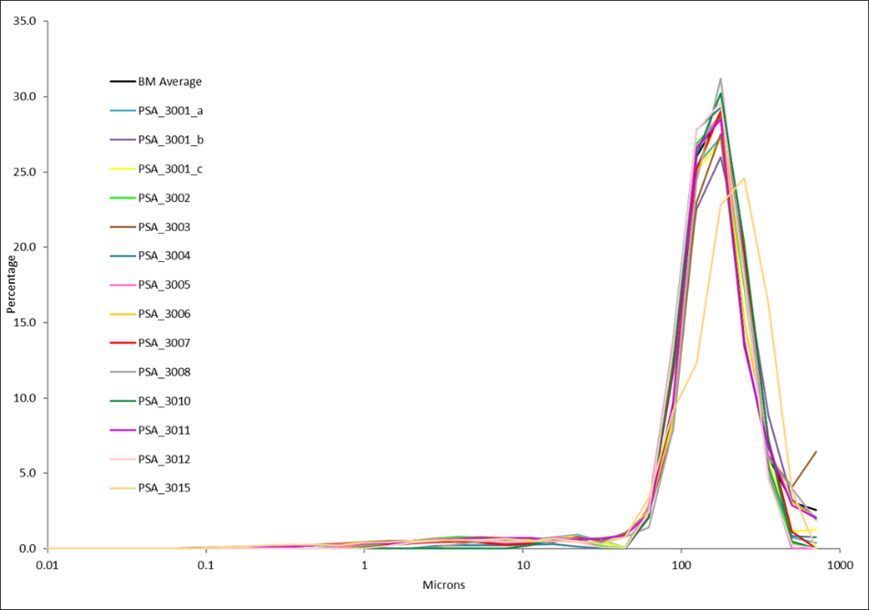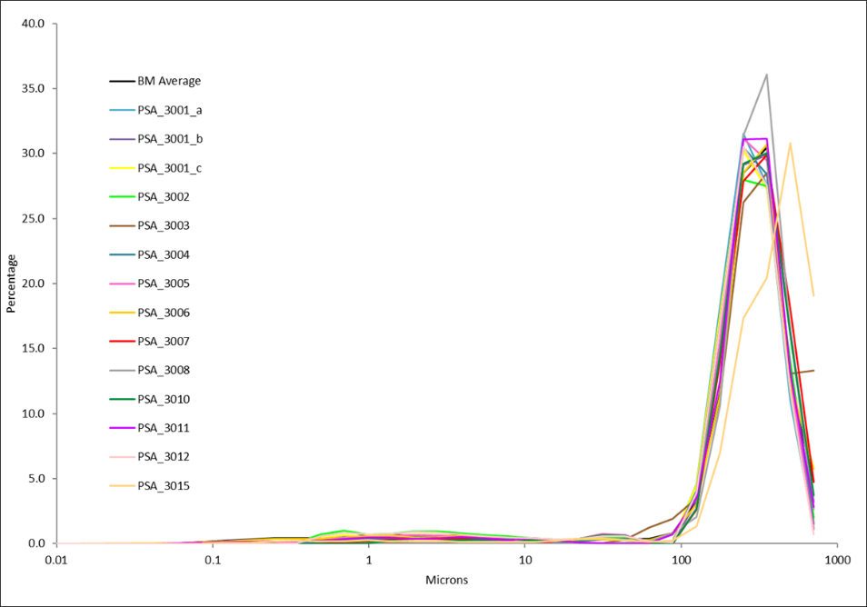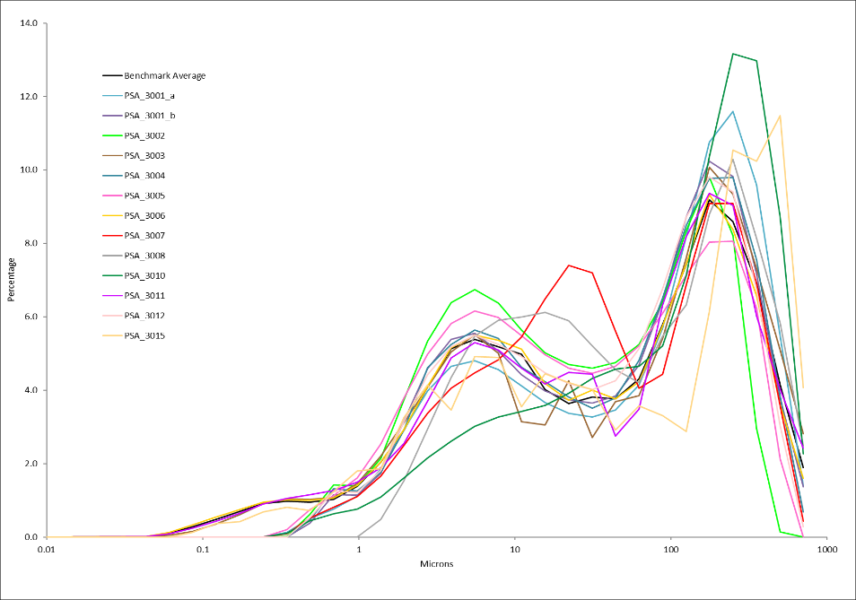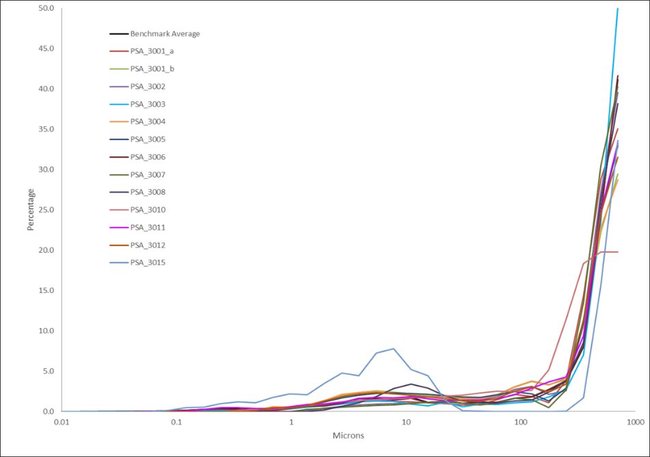
Figure 10. Differential final laser data provided by participants for exercises PS88 (top left), PS89 (top right), PS90 (bottom left) and PS91 (bottom right).

For Exercises PS88, PS89, PS90 and PS91 all the participants that submitted metadata are now using the Mie Theory analysis model. All of the participants that provided metadata information used a Particle Absorption Index of 0.1. Most participants used a Particle Refractive Index of 1.55 while two participants used a Particle Refractive Index of 1.52 (PSA_3010 and PSA_3012). All participants using Beckman Coulter laser analysers used the PIDS (Polarized Intensity Differential Scattering) system as the fines extension; all participants using Malvern Mastersizer instruments used both the red and blue light wavelengths.
There remains a degree of variation in the pump and stirrer speeds and the use of ultrasonics. These factors are probably mostly responsible for the variation in the laser size distributions seen in Figure 10. It is not always obvious why a result appears to be different without detailed laser metadata. In addition to laser instrument set-up conditions and performance there are other factors that could be affecting the results, including sample preparation, sample dispersion methods and sample presentation to the laser instrument, about which little or no information has been provided.

Application of NMBAQC Scheme Standards and Laboratory Performance
One of the key roles of the Particle Size Analysis component of the NMBAQC Scheme is to assess the reliability of data collected as part of the Clean Seas Environment Monitoring Programme (CSEMP; formerly UK NMMP) and Water Framework Directive (WFD) monitoring programmes. With this aim, performance target standards were defined for certain Scheme modules and applied in 1996/97 (Scheme year three). These standards were the subject of a review in 2001 (Unicomarine, 2001) and were altered in Scheme year eight; each performance standard is described in detail in the Description of the Scheme Standards for the Particle Size Analysis Component document. An overall summary of the data reported by each participant is presented in each of the PS exercise reports, and along with this each participant receives a results table outlining their individual performance. In previous years laboratories meeting or exceeding the required standard for a given exercise would be considered to have performed satisfactorily for that particular exercise; a flag indicating a “Pass” or “Fail” would be assigned to each laboratory for each of the exercises concerned. As the Pass/Fail criteria are still under review for the PS exercises, in 2023/24 (Scheme year 30) a “Good” or “Review” flag has been issued for Sieve analysis (>1mm), Laser Analysis (<1mm) and Final Data. This aims to highlight any potential errors but will not be used to assess the performance of a laboratory. As this is a training exercise rather than a proficiency test, participants are encouraged to review their results especially where “Review” flags have been issued and can re-submit improved data after the issue of the interim report. Each laboratory was issued with a Statement of Performance certificate outlining their results and participation in the Scheme.

Particle Size Own Sample Analysis (PS-OS) module

Description
The Particle Size Own Sample (PS-OS) module was first introduced in Scheme year 21 (2014/15) as a training/audit module and now is in its ninth year of operation. Participants’ “own” samples are re-analysed by the NMBAQC Scheme PSA contractor and the results are compared. The purpose of this exercise is to examine the accuracy of particle size analysis for participants’ in-house samples. In its first year (2014/15) the PS-OS exercises carried a trial Pass/Fail criterion based on the correlation between the participant data and the AQC data. After discussions between KPAL, APEM and the Scheme’s PSA Contract Manager (Claire Mason, Cefas), it was decided that a more simplistic approach to analysing the results would be more appropriate in identifying errors in participants’ results. The results now follow a similar format to the PS exercises and were split into sieve processing, laser processing and final data. Participants received a “Good” or “Review” flag based on their results. Where a “Review” flag was issued comments were supplied detailing problems that had arisen and where to find information to help address them.

Analysis required
Laboratories were requested to submit details of a survey with at least 12 samples from their previous year's Clean Seas Environment Monitoring Programme (formerly NMMP) samples, or similar alternative sampling programmes (if not responsible for CSEMP samples), along with the associated PSA data. Once these data were provided, three samples were randomly chosen by APEM Ltd to be re-analysed by the NMBAQC Scheme’s PSA contractor.
Spreadsheet based workbooks were distributed to each participating laboratory via email for each PS-OS exercise. These were to be returned to APEM Ltd via the NMBAQC Scheme email address (nmbaqc@apemltd.co.uk).
In each workbook a written description of the sediment classification was to be recorded, a visual estimate was made prior to analysis and a post analysis classification based on the percentages of gravel, sand and silt/clay and the Folk (1954) terminology. Any use of hydrogen peroxide treatment or chemical dispersant was also to be recorded. Also requested was a breakdown of the particle size distribution of the sediment, expressed as a weight or weight percentage of sediment in half-phi () intervals, as well as sieve and laser metadata to provide insight into laboratory procedures, especially for the laser analysis.
The different components of each PS-OS sample (< 1mm, > 1mm and laser sub-sample) were to be sent to APEM’s Letchworth laboratory to be passed on to the NMBAQC Scheme PSA contractors. The two sets of results were then compared by APEM Ltd.
Following on from delays resulting from the Covid-19 pandemic the timetable for the PS-OS module was altered to allow participants more time to submit data and to speed up reporting of results to participants. Participants who took part in Batch 1 submitted data by 15th November 2023, had samples selected by the 26th January 2024 and reports were issued at the end of April 2024; Batch 2 submitted data by 22nd March 2024, had samples selected by the 26th April 2024 and reports were issued by the end of July 2024.

Results

General comments
Nine laboratories subscribed to the PS-OS module in 2023/24. All laboratories that subscribed to the module provided data and samples for re-analysis. Four participants submitted data in Batch 1 and five participants submitted data in Batch 2.
Each laboratory received detailed comparisons of their data with the re-analysis results obtained by the NMBAQC Scheme’s contractor. Where the original analysis was performed by the Scheme’s contractor an external auditor was used to re-analyse the samples. Results were split into sieve processing, laser processing and final data. At the end of each report participants received a “Good” or “Review” flag based on their results; where “Review” flags were issued, comments were made on errors that had arisen and where possible information was provided to help resolve problems.
Most of the laboratories that provided samples provided all necessary fractions of their sample for re-analysis; participant PSA_3010 who provided a dried laser sub-samples and therefore this required re-wetting and mixing into a soft but stiff paste consistency in order to extract representative laser subsamples. Participant PSA_3005 bagged the sediment retained on each sieve in the original analysis separately. The AQC laboratory noted that this makes it difficult to empty 100% of the sample from the bags, potentially leading to slight underestimation of the sample weight, although every effort was made to extract as much sediment as possible. There is no need to bag each individual sieve fraction, particularly as this only serves to hamper rather than hinder any reanalysis. Participant PSA_3020 only provided the remaining bulk sample indicating the whole sample had not been fully processed in the first instance.
There was generally good agreement between the participants and the AQC results, particularly in terms of basic sediment textural classification (see Table 5). Differences are highlighted in blue.

Table 5. Gradistat sediment descriptions from the primary data and the AQC re-analysis. Taken from Table 5 of the individual PS-OS reports.
Lab | Sample | Primary Sediment Description | AQC Sediment Description
PSA_3003 | PS-OS 28  PS-OS 29  PS-OS 30 | Muddy Sandy Gravel  Slightly Gravelly Sand  Gravelly Muddy Sand | Muddy Sandy Gravel  Slightly Gravelly Sand  Gravelly Muddy Sand
PSA_3004 | PS-OS 28  PS-OS 29  PS-OS 30 | Gravelly Sand  Slightly Gravelly Sand  Slightly Gravelly Sand | Gravelly Sand  Slightly Gravelly Sand  Slightly Gravelly Sand
PSA_3005 | PS-OS 28  PS-OS 29  PS-OS 30 | Slightly Gravelly Muddy Sand  Slightly Gravelly Muddy Sand  Slightly Gravelly Sand | Slightly Gravelly Muddy Sand  Slightly Gravelly Muddy Sand  Slightly Gravelly Sand
PSA_3006 | PS-OS 28  PS-OS 29  PS-OS 30 | Slightly Gravelly Sand  Gravelly Sand  Slightly Gravelly Sand | Slightly Gravelly Sand  Gravelly Sand  Slightly Gravelly Sand
PSA_3010 | PS-OS 28  PS-OS 29  PS-OS 30 | Slightly Gravelly Muddy Sand  Slightly Gravelly Muddy Sand  Slightly Gravelly Sand | Slightly Gravelly Muddy Sand  Slightly Gravelly Muddy Sand  Slightly Gravelly Sand
PSA_3011 | PS-OS 28  PS-OS 29  PS-OS 30 | Slightly Gravelly Sandy Mud  Sandy Mud  Muddy Sandy Gravel | Slightly Gravelly Sandy Mud  Sandy Mud  Muddy Sandy Gravel
PSA_3012 | PS-OS 28  PS-OS 29  PS-OS 30 | Slightly Gravelly Muddy Sand  Slightly Gravelly Sandy Mud  Slightly Gravelly Sandy Mud | Slightly Gravelly Muddy Sand  Slightly Gravelly Sandy Mud  Slightly Gravelly Sandy Mud
PSA_3020 | PS-OS 28  PS-OS 29  PS-OS 30 | Sand  Muddy Sand  Muddy Sand | Gravelly Muddy Sand  Gravelly Muddy Sand  Slightly Gravelly Muddy Sand
PSA_3021 | PS-OS 28  PS-OS 29  PS-OS 30 | Sandy Gravel  Gravelly Sand  Gravelly Sand | Muddy Sandy Gravel  Gravelly Muddy Sand  Gravelly Muddy Sand

Participant PSA_3020 appeared to have only undertaken analysis on the <1.0mm fraction of the sample despite >1.0mm material being present in the bulk sample they supplied. At the time of writing this report it is unclear whether this is a difference in methodology, project requirements or a genuine error.
Participant PSA_3021 follow a different methodology as they do not have a laser analyser, samples are sieved to 63µm which explains the difference in textural group. The AQC analysis followed the NMBAQC methodology and therefore recorded a higher percentage of fine material. This participant also provided >1.0mm, <1.0mm fractions as well as the remaining bulk sample indicating the full sample had not been processed. Due to this participant PSA_3021 is only assessed on the >1.0mm fraction which is directly comparable with the AQC data.
Other than PSA_3020 where no sieve analysis on the >1.0mm was undertaken, the greater than 1mm data created by dry sieving was in general very good, there were a few discrepancies, but these are to be expected due to factors such as breakage of particles during repeat analysis and variations in sieving time and vibration amplitude.
Small amounts of variability particularly in percentage clay shown in Figures 11, 12 and 13 can be explained by differing laser instruments used by the AQC lab and participants. As discussed earlier in this report, the Malvern Mastersizer 2000 and 3000 instruments do not have the same resolution as the Coulter LS13320, especially at the finer end; the Coulter uses a PIDS (Polarization Intensity Differential Scattering) system at the bottom end, rather than diffraction, so provides better sensitivity than the Malvern system which employs diffraction of two different wavelengths of light (red and blue). Often the Coulter system reports higher mud content than the Malvern machines and the distributions produced by the Malvern tend to be more smoothed, and less able to identify discrete size modes. The output size distribution from the Malvern instruments machines is very dependent on the diffraction pattern interpretation model used; this can be selected by the operator as "General Purpose, Unimodal, and Multimodal etc.” and can give rise to uncertainty. There is no such specification requirement with the Coulter instruments.

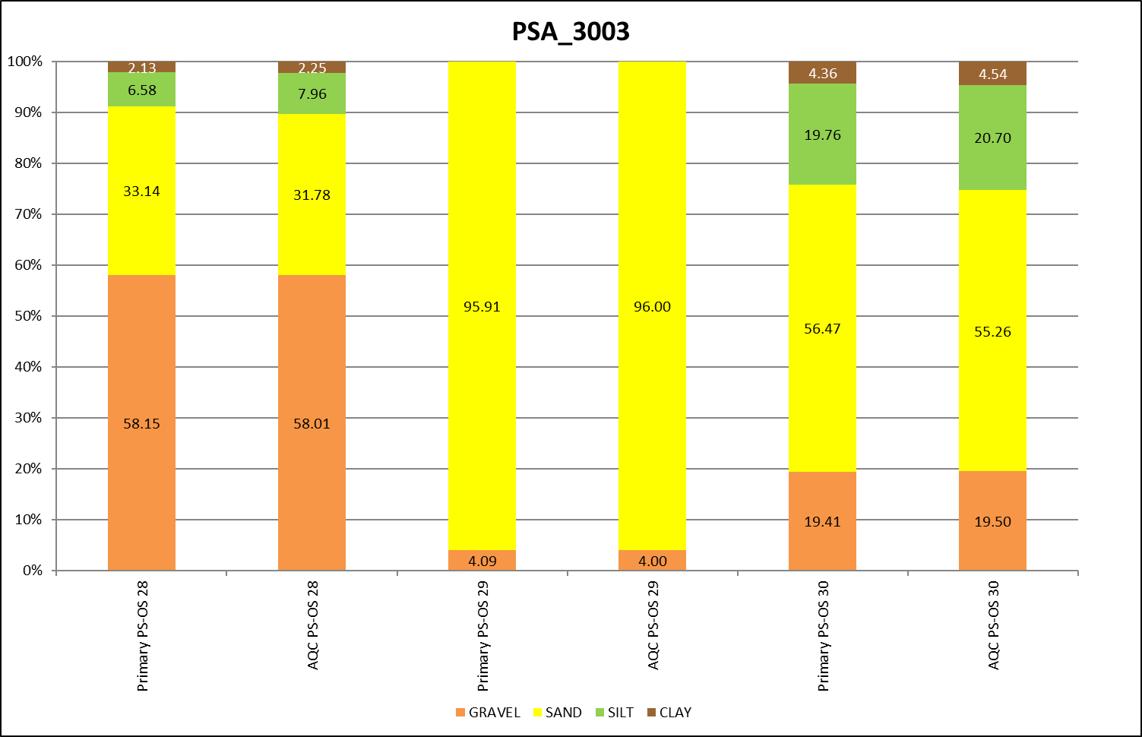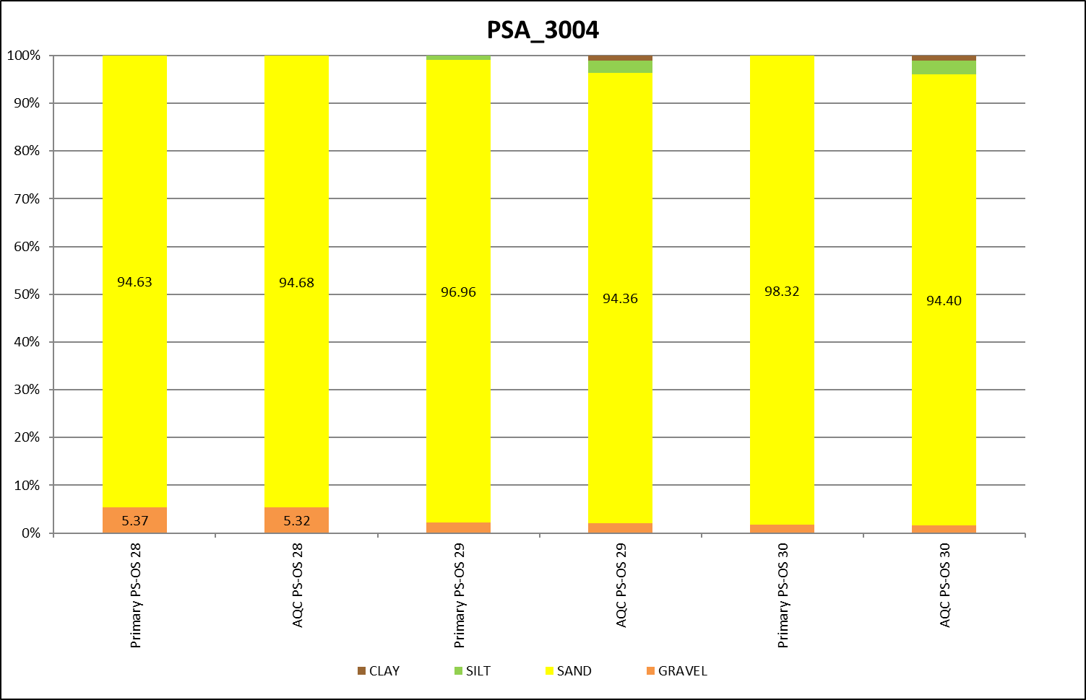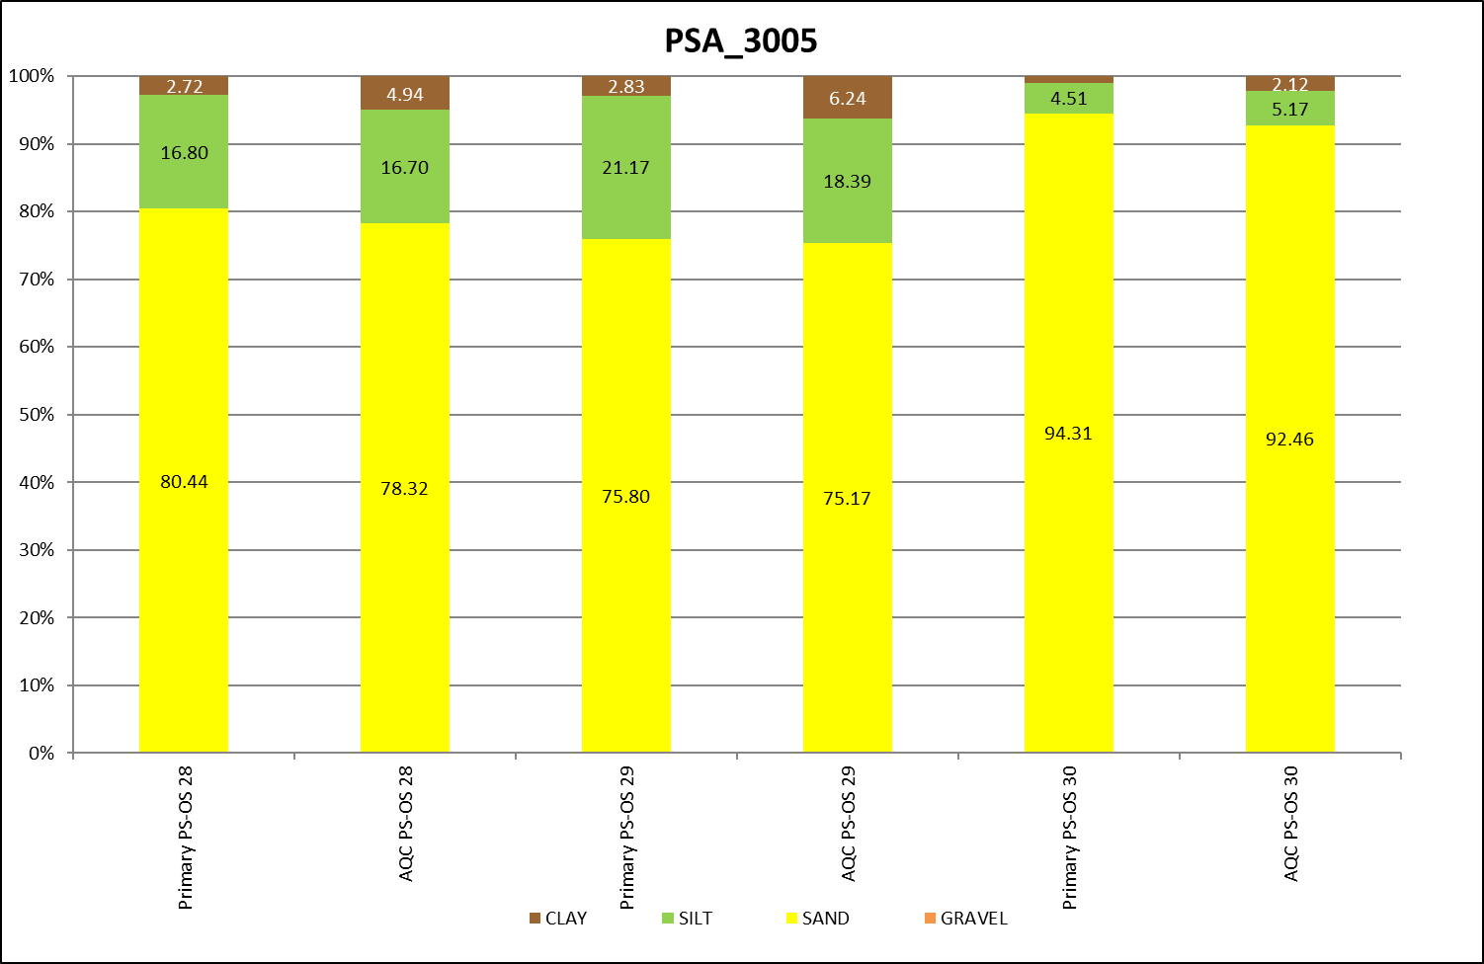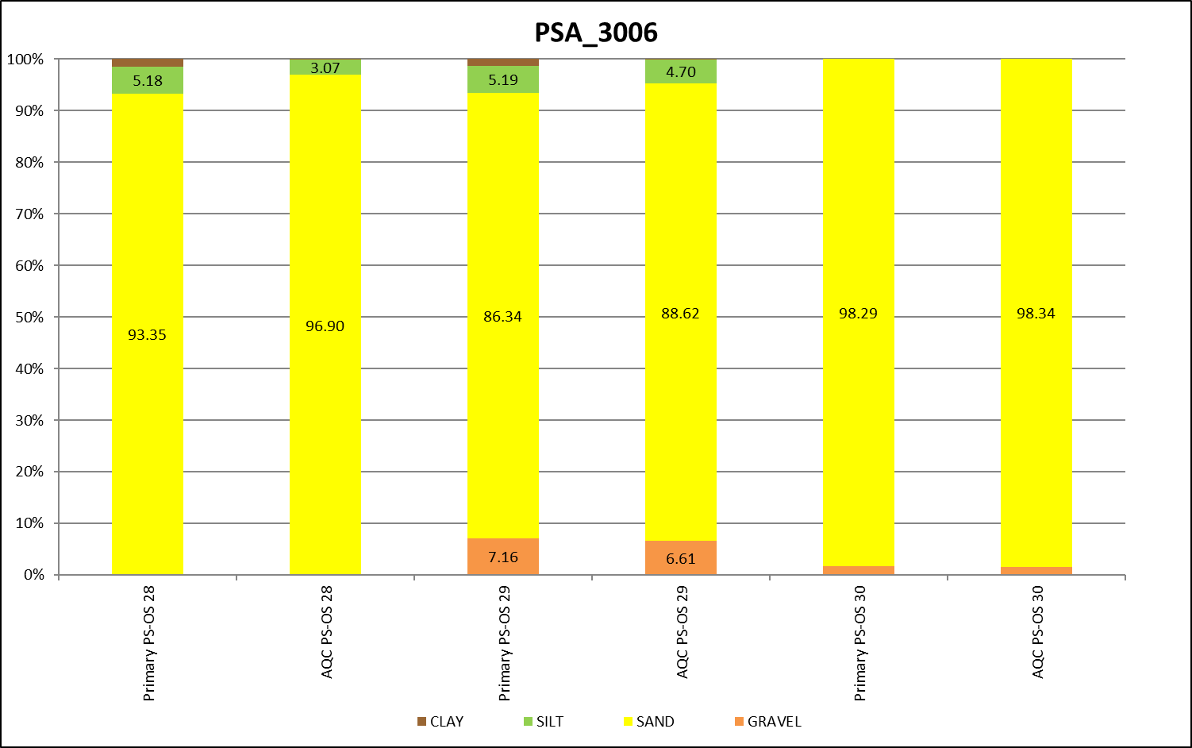
Figure 11. Bar charts showing percentage gravel, sand, silt, and clay in the PS-OS module from laboratories PSA_3003, PSA_3004, PSA_3005 and PSA_3006.
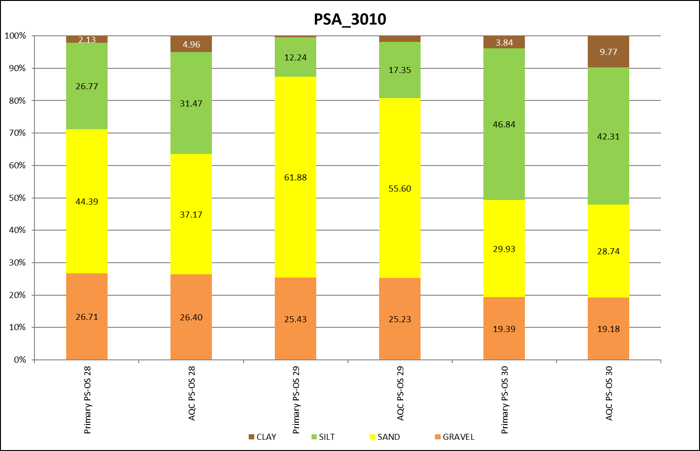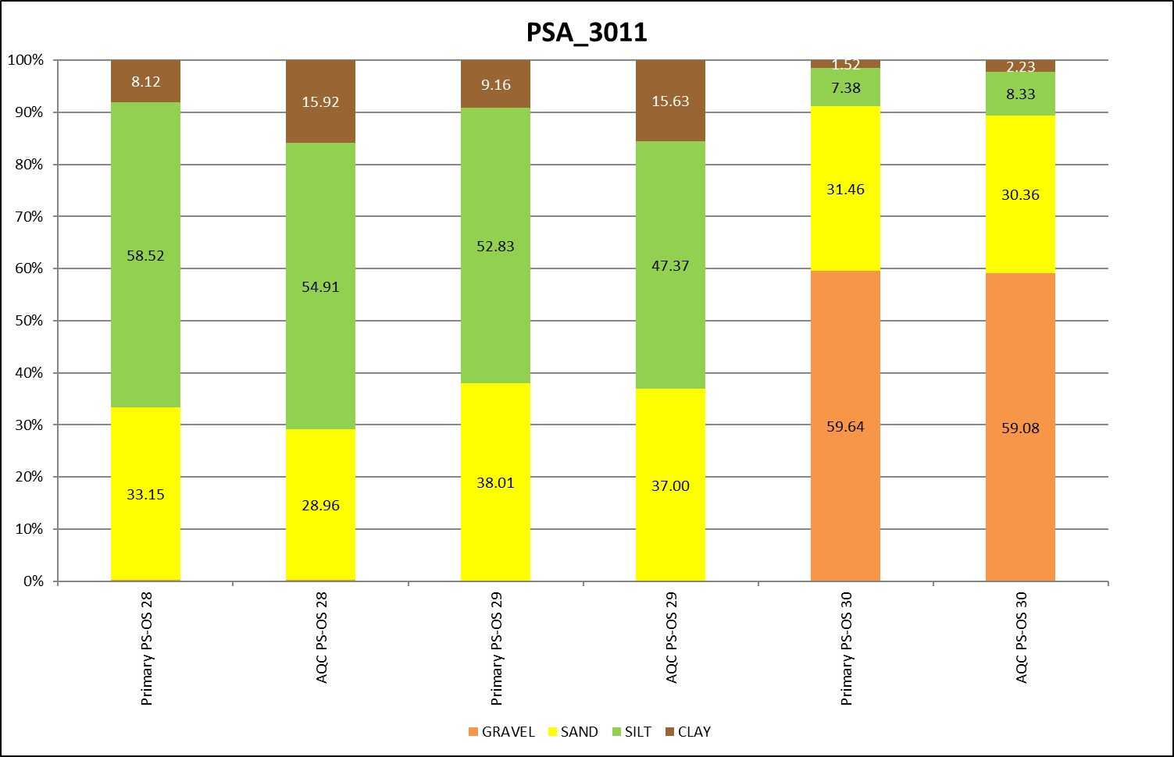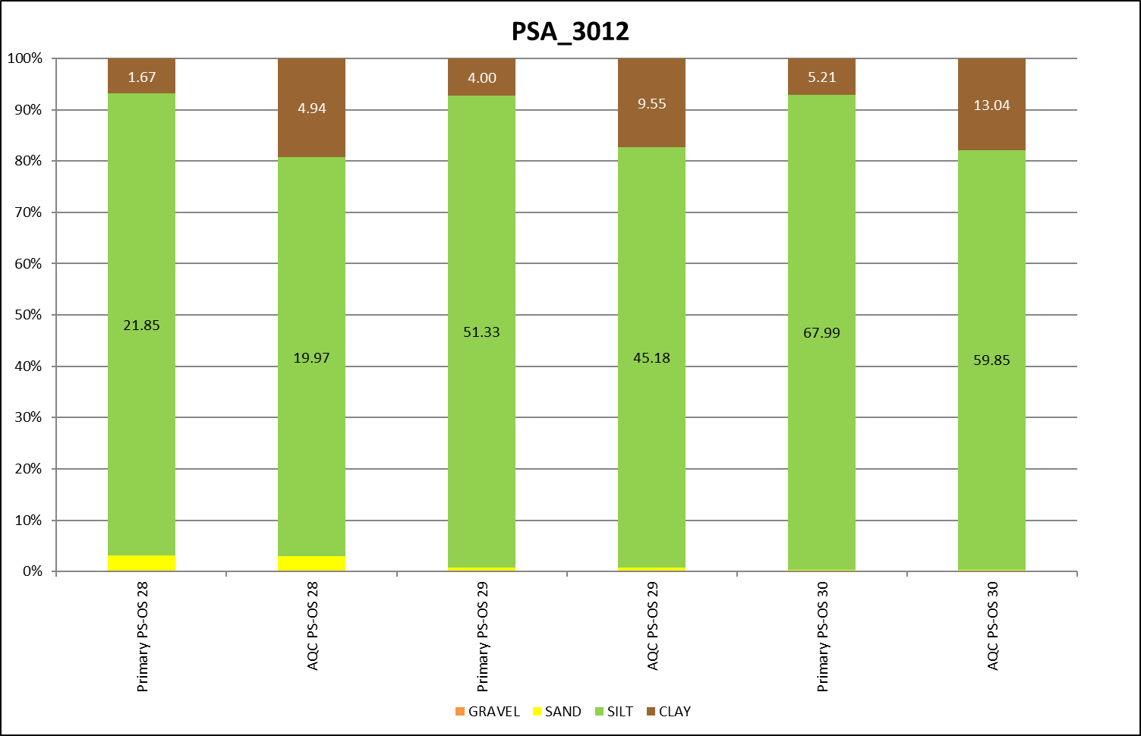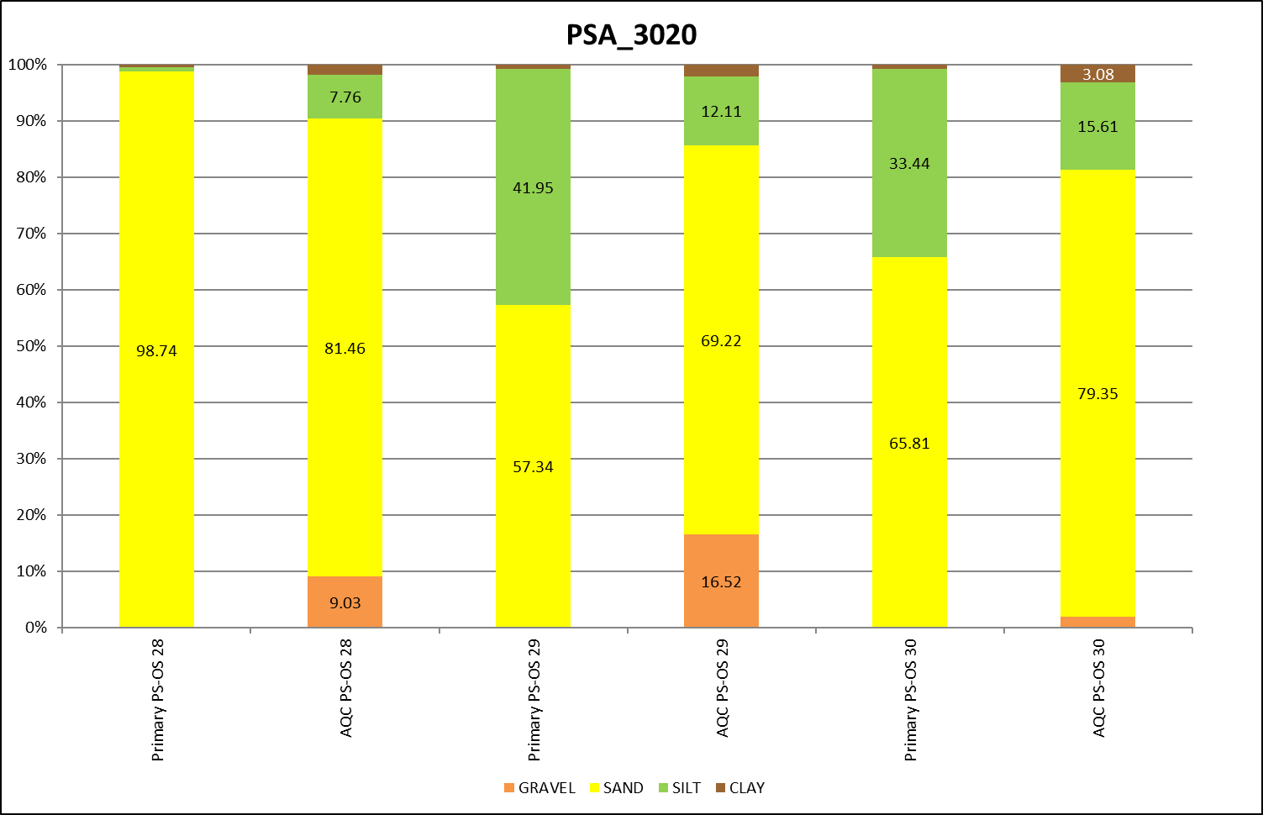
Figure 12. Bar charts showing percentage gravel, sand, silt, and clay in the PS-OS module from laboratories PSA_3010, PSA_3011, PSA_3012 and PSA_3020.
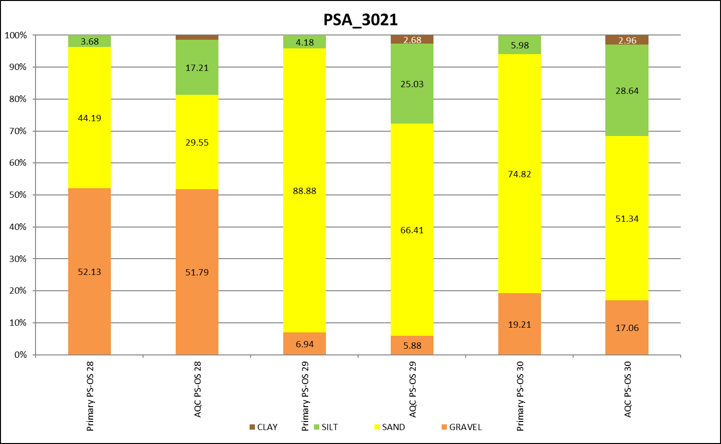
Figure 13. Bar charts showing percentage gravel, sand, silt, and clay in the PS-OS module from laboratory PSA_3021.

Discussion
As in previous years, differences in laser analysis are still the main area of concern in the PS-OS samples. The interpretation of the methodology set out in the NMBAQC Best Practice Guidelines (Mason, 2022), in particular how the laser analysis is undertaken still appears to be a possible issue in some cases. These guidelines, originally written in 2011, were based on the widespread use at that time amongst participants of Malvern Instruments laser diffraction instruments that have 15 – 25 second standard run times and generally are restricted to the analysis of material < 1mm in size. The original methodology suggested that:
- A homogenised sub-sample of approximately 100ml is taken from the bulk sample for laser analysis (Laser Pot).
- A small representative sub-sample is taken from the Laser Pot and passed through a 1mm sieve using as little water as possible (Replicate 1).
- All of Replicate 1 is then run through the laser at the desired obscuration, producing three run results.
Steps 2 and 3 are then repeated to create Replicates 2 and 3, giving a final result of 9 runs to create the final laser data, the average of these 9 runs.
The completion of nine analyses, and subsequent merging of results is necessarily a time-consuming process, especially if standard run times longer than 15 to 25 seconds are used (e.g. 60 seconds is standard with Beckman Coulter instruments (if the PIDS system is activated). It has been demonstrated by KPAL that, for most samples, there is little practical benefit in routinely carrying out analysis of three replicate sub-samples if samples are homogenised properly both before the laser sub-sample is taken from the bulk sample and when the test sample is taken from the laser sub-sample, and the sample is adequately dispersed prior to presentation to the instrument. In relatively rare instances where samples consist very largely of > 1mm size material and it is impractical to obtain a representative laser sub-sample from the bulk sample, more consistent laser results can be obtained by taking a laser sub-sample from the wet separated < 1mm fraction of the sediment, rather than from the bulk sample.
Where samples display, or are suspected of, unstable behaviour, such as time-dependent agglomeration, one or more repeat runs of the same test sample should be carried out, and additional replicate test samples analysed. Sometimes this may require repeat runs of more than three replicates to fully characterise agglomerative behaviour, and to establish the best dispersal procedures required to obtain repeatable results (e.g. ultrasonic treatment before as well as during the analysis run, and/or use of chemical dispersants). If the laser sub-sample is visually heterogeneous, and/or during the preparation of the test sample it is observed that small amounts of sand are present within a mainly muddy matrix, two or more test samples should be analysed. Additionally, for QA purposes, it is good practice to carry out at least duplicate analysis on 1 in 10 samples. The guidance has been updated to incorporate most of these findings and recommendations, with some further follow up expected at future NMBAQC PSA workshops. The most recent version of the guidance can be viewed in Mason (2022).
The returns for the 2023/24 PS-OS module showed that some laboratories, particularly those using Coulter instruments, in routine case work only run one laser test sample, with, for QA demonstration purposes, replicates run every 10th, 20th or 50th sample, dependent on sediment type (less frequently for well sorted uniform sand samples than for poorly sorted muddy sand and muddy sandy gravel mixtures). The results obtained by KPAL, for the NMBAQC replicates samples prepared by APEM since 2014/15, demonstrate that the high degree of repeatability which can be obtained when strict analysis protocols are followed, and that a high degree of confidence can be placed in the results obtained for any individual analysis.
The PS-OS module also revealed that a few participants do not follow the NMBAQC methodology for routine samples. This generally occurs when a participant does not have access to a laser analyser, in this case only the sieve and final data can be compared. Participants are encouraged to participate even when samples have been analysed following a different methodology as long as details of the methodology used are presented clearly. Although re-analysis will be undertaken following the NMBAQC methodology this gives a chance to compare how results differ when using alternate methodologies. Using a different methodology will always be taken into consideration when comparing the primary and AQC analysis.

Conclusions and Recommendations
A number of observations may be made based on the results of the exercises described above. The following is a summary of the major points of importance.
- Laboratories should ensure that they follow the NMBAQC methodology when participating in the Particle Size (PS) Ring Test. The PS Ring Test is designed to test whether all participants are getting comparable results when they follow the same methodology. It is therefore important that only the NMBAQC methodology (Mason, 2022) is used where possible and that results for 3 x 3 laser analyses are provided. If an alternate methodology has been used it is imperative that the differences to the NMBAQC methodology are shared so that results can be fairly assessed. Participants who do not have access to a laser analyser will be permitted to use alternate methods for samples that contain sediment less than 1mm as long as the method used is detailed in the summary section of the workbook. Participants can choose to opt out of either the sieve or laser aspects if they do not routinely undertake that type of analysis. The participant must let the administrator know at the start of the scheme year if they wish to opt out of any analysis. Results will only be provided for the analysis that was undertaken and a note will be put on the Statement of Performance that the participant has opted out of certain points.
Samples for the PS-OS module can be analysed following alternative in-house methods however these must be thoroughly described and the participant should be aware that re-analysis will be undertaken following the NMBAQC methodology. Samples provided for PS-OS which have been routinely analysed do not necessarily have to provide 3 x 3 laser analysis data but should show that appropriate QC checks have been carried out, including on the final data set.
- Participants should review their data prior to submission. Errors in datasets can often be spotted in the summary statistics, e.g. percentage gravel, sand and silt/clay, before the data are submitted. All parts of the workbook should be double checked before submission to ensure that they have all been completed correctly. This will help eradicate typing and transcription errors. The workbook was updated for the current Scheme Year (Year 28) to help enable the continuity of data through the workbook. Conditional formatting flags up red cells where there are possible data entry errors.
- The current NMBAQC Scheme Pass/Fail criteria for the PS modules are under review. Currently results are broken down for review, including sieve processing, laser processing and final data. Laboratories then received a “Good” or “Review” flag based on their results; “Review” flags came with accompanying comments as to where mistakes have been made and how to correct them. This approach was thought to be more informative and would help participants to identify errors and correct any issues for future exercises. Following the publication of ‘Statistical comparisons of sediment particle size distributions’ (Barry et al., 2021) in Continental Shelf Research, data from previous and future reports will trial this new statistical method of comparing the benchmark and participant data to understand if we can achieve a pass/ fail criteria for the particle size component, with the possibility of a report detailing the outcomes available in the next couple of scheme years.
- A Review is not a fail. Although every attempt is made to ensure that all replicates are as similar as is humanly possibly there will naturally be some variation, particularly in natural mud samples. A review flag is just to point out that your analysis does differ from that of the Benchmark Lab and other participants. We encourage participants to review their data and if required request a new replicate or ask for their replicate to be re-analysed by the Benchmark Lab for a comparison.
- A comparison study for different laser manufacturers and models is currently underway. This study will help to assess the variation between different laser models for different sediment types including muds, sandy muds, muddy sands and sands. Once complete, data and outcomes obtained will be published in the NMABQC PSA guidance document.

References
Blott, S.J. and Pye, K. 2001 GRADISTAT: a grain size distribution and statistics package for the analysis of unconsolidated sediments. Earth Surface Processes and Landforms 26, 1237-1248.
Blott, S.J. & Pye, K. 2012 Particle size scales and classification of sediment types based on size distributions: review and recommended procedures. Sedimentology 59, 2071-2096.
Folk, R.L., 1954. The distinction between grain size and mineral composition in sedimentary-rock nomenclature. Journal of Geology 62, 344-359.
Hall, D.J. 2010 National Marine Biological Analytical Quality Control Scheme. Description of Scheme Standards for the Particle Size Analysis Component from Scheme Year 8 (2001/02) to Year 16 (2009/10). Report to the NMBAQC Scheme participants. Unicomarine report NMBAQCpsa_stds, February 2010.
Mason, C. 2022. NMBAQC's Best Practice Guidance. Particle Size Analysis (PSA) for Supporting Biological Analysis. National Marine Biological AQC Coordinating Committee, 84pp, First published 2011, updated March 2022.
McIntyre-Brown, L. & Hall, D., 2024. National Marine Biological Analytical Quality Control Scheme. Particle Size Results: PS88 Report to the NMBAQC Scheme participants. Apem Report NMBAQCps88, 19pp, June 2024.
McIntyre-Brown, L. & Hall, D., 2024. National Marine Biological Analytical Quality Control Scheme. Particle Size Results: PS89 Report to the NMBAQC Scheme participants. Apem Report NMBAQCps89, 19pp, June 2024.
McIntyre-Brown, L. & Hall, D., 2024. National Marine Biological Analytical Quality Control Scheme. Particle Size Results: PS90 Report to the NMBAQC Scheme participants. Apem Report NMBAQCps90, 16pp, July 2024.
McIntyre-Brown, L. & Hall, D., 2024. National Marine Biological Analytical Quality Control Scheme. Particle Size Results: PS91 Report to the NMBAQC Scheme participants. Apem Report NMBAQCps91, 17pp, July 2024.
Unicomarine. 1995 National Marine Biological Quality Control Scheme. Annual Report (Year one). Report to the NMBAQC Committee and Scheme participants. September 1995.
Unicomarine. 1996 National Marine Biological Quality Control Scheme. Annual Report (Year two). Report to the NMBAQC Committee and Scheme participants. September 1996.
Unicomarine. 2001 National Marine Biological Analytical Quality Control Scheme. Own Sample Format and Standards Review: Current Problems and Proposed Solutions. Report to the NMBAQC Committee. April 2001.

